Open Grid Forum Reference Model
v2.0D DRAFT

Status of This Document
This document provides information to the Grid community on a reference model for grid components and how they can be organized and managed. Distribution is unlimited.

Obsoletes
This document obsoletes the Enterprise Grid Alliance (EGA) Reference Model and Use Cases Part 1 of 2, version 1.5, 10th March 2006.

Revision History
Version | Date | Comments
1.0 | 13th April 2005 | Approved by EGA board as a public document.
1.5 | 10th March 2006 | Added extensive set of use cases and created a two part document – EGA Reference Model and Use Cases Parts 1 and 2.
2.0A DRAFT | 7th June 2007 | Reformatted and numbered to OGF standard.  Formalized description of Grid Components and their life cycle using the UML v2.0.
2.0B DRAFT | 20th June 2007 | Refined
2.0C DRAFT | 5th Dec 2007 | Updated diagrams and text for sections
2.0D DTAFT | 8th Jan 2008 | Incorporated updated Lifecycle and other edits.

Copyright Notice
Copyright © Open Grid Forum (2007, 2008). All Rights Reserved.

Trademark
Open Grid Services Architecture and OGSA are trademarks of the Open Grid Forum.
Abstract
The Reference Model is the basis for describing complex distributed infrastructures and services, i.e. Grids, in terms of a set of relatively simple components, interactions and life cycles. The model thus provides the context for solving the problems associated with managing these environments. This document provides both an informal description of the concepts that underpin the reference model, and a formal definition (UML 2.0 and annotation) of that model.
Contents
1. Introduction 7
1.1 General 7
1.2 The Goals of the Reference Model Working Group 7
1.3 Reference Model Development Plan 8
1.4 Notational Conventions 8
2. Reference Model Key Concepts 9
2.1 Introduction 9
2.2 Grid Components 10
2.2.1 Definition 10
2.2.2 The Grid Component 12
2.2.2.1 Common Attributes 12
2.2.2.2 Configuration Information Attribute 12
2.2.2.3 State Information Attribute 12
2.2.3 LifecycleManagement Interface 12
2.2.3.1 Lifecycle States 13
2.2.3.2 State Transition Interface 15
2.2.3.3 Lifecycle Attributes 19
2.2.4 Associations 20
2.2.4.1 Interaction Dependencies 20
2.2.4.2 Instantiation Dependencies 20
2.2.5 Pattern Components 20
2.2.6 The Manager Component 21
2.2.7 The Policy Class 21
2.2.8 The Relationships Between The Core Grid Component Classes 21
2.2.8.1 The Pattern Component 21
2.2.8.2 The Manager Component 21
2.2.8.3 Managed Grid Components 22
2.2.9 Viewing Dependencies 22
2.2.10 Attributes and Properties 23
2.2.11 Classification 24
2.2.12 Grid Component Summary 26
2.3 The Grid Management Entity 26
2.3.1 Definition 26
2.3.2 The Role Of The GME 28
2.3.3 The Grid Component Life Cycle From The Perspective Of The GME 29
2.3.4 Orchestrating Grid Components 30
2.3.5 Policy Based Management 32
2.3.5.1 General 32
2.3.5.2 Goals - SLOs And SLAs 32
2.3.5.3 Constraints 33
2.3.5.4 Configurations 33
2.3.5.5 Rules 34
2.3.5.6 Applying And Deriving Policy 34
2.3.5.7 Policy Implementation 34
2.3.6 Service Level Management 34
2.3.6.1 General 34
2.3.6.2 Initial Deployment 38
2.3.6.3 Workload Management And Optimization 39
2.3.6.3.1 Monitoring 39
2.3.6.3.2 Reconciliation, Billing & Accounting 39
2.3.6.3.3 Resource Optimization And Balancing 40
2.3.6.3.4 Reallocating 40
2.3.7 GME Functional Breakdown 41
2.3.7.1 General 41
2.3.8 GME Summary 43
3. Appendix A – Lifecycle Example WSDL 44
4. Security Considerations 52
5. Contributors 52
5.1 EGA Reference Model Contributors 52
5.2 OGF Reference Model 2.0 Contributors 53
6. Glossary 54
7. Intellectual Property Statement 65
8. Disclaimer 66
9. Full Copyright Notice 67
10. References 68

Figures
Figure i - The Grid Component 11
Figure ii - Reference Model Lifecycle States and Transitions 13
Figure ii – Pattern Components, Manager and Managed Grid Components 21
Figure iii - A Grid Component Instantiation Dependency Graph 24
Figure vi - Some Grid Component Classes 26
Figure vii - The GME As Logically Separate From The Grid Components 28
Figure viii - GME Functionality Embedded In Grid Components 29
Figure ix - The Grid Management Entity 30
Figure xi - The GME And Service Level Management 37
Figure xii - Hierarchical SLM 38
Figure xiii - Hierarchical SLM showing GME functionality within a realized grid component - i.e. a database cluster 39
Figure xiv - Mapping of logical GME components within the GME to managed grid components 43
Figure xv - GME Functional Breakdown 45

Introduction

General
Grid computing captures the notion of network-distributed applications, i.e. services, running on a distributed, integrated and shared, platform, i.e. a Grid. It is this notion of sharing and integration that differentiates Grids from what has gone on before, for example traditional data centers or clusters of computers.
Grids, by being network based and distributed, offer opportunities for scale, throughput, resilience and so forth. These properties may be applied to all classes of application, whether transactional, compute intensive or batch. A Grid’s infrastructure may exist within an organization, for example in the case of Enterprise Grids, or it may span multiple organizations. Likewise the services that run on a Grid may be owned by one organization, as is often the case in Cluster Grids, or shared by many, as in Collaborative Grids. All of these infrastructures are Grids. Categorizing them serves to allow domain specific problems to be more easily addressed and use cases defined.
Grids, by their very nature, encourage the movement away from the use of relatively small numbers of large, complex and expensive resources, such as large SMP computers to, large numbers of relatively cheap and simple resources, such as commodity computers. However, as these Grids grow in size, they themselves become extremely complex. Linearly increasing the number of components within a Grid, results in an exponential increase in its complexity as new relationships with existing components are also added. Ultimately the constraints on realizing value from Grids shifts from being those of making the applications or services scale, to those of managing them.

The Goals of the Reference Model Working Group
The goals of the reference model working group are to provide -
- A common set of terms to be used with respect to grids, the components that comprise Grids, their relationships with one another and their life cycles. The definition of new terms is not a goal. Rather, where possible, it is to provide some precision around terms in common use but which are directly applicable to the work of the OGF working groups. Some new terms which have very specific meaning with respect to the reference model itself are defined, nonetheless, in general, the goal is to use, leverage and cross-reference as much as possible, for example the OGSA Glossary [13].
- A Reference Model that defines a common context in terms of enumerating and classifying the set of components within a grid, the relationships between them, their life cycles and how they are managed. This is intended to include as simple a core model as possible, making it easy to understand and easy to extend, yet still ensuring that it still capable of adequately representing the richness and complexity inherent in deployed Grids. Some of the work will be OGF specific, but the goal is not to reinvent the wheel, so to speak, but rather to leverage wherever possible. Thus the initial, high level, generalized specification will be quite OGF specific, but the more detailed and specific definitions to follow in future versions of this document will probably cross reference other standards or work, for example the Common Information Model (CIM) from the Distributed Management Task Force (DMTF) or the Open Grid Services Architecture (OGSA). At present, no other bodies adequately capture the high level nature of the components within a grid, their life cycle and how these are managed within a single model. The goal is for the OGF to make a start here and to provide impetus to the bodies that already own parts of the picture (DMTF, SNIA etc.), to either unify their models or at least make them consistent with each other.
TBD – Need to check status of ITIL3 which purportedly now has an information model.

Reference Model Development Plan
Version 2 of the Reference Model is focused on formalizing the model described in version 1.5 of the EGA Reference Model and relating it to other models within and without the OGF.
- v2.0 will focus on formalizing the existing reference model.
- v2.1 will focus on relating this model to other models within the OGF, for example OGSA, OGSA Information Model, GLUE Schema, JSDL, CDDLM etc.
- v2.2 will focus on relating this model to other models outside of the OGF, including, but not necessarily limited to the DMTF’s CIM, SNIA’s SMI-S, the TMF’s eTOMS and SID, OASIS’s DCML and ITIL.
Subsequent versions will focus representing the model in RDF/RDFS Vocabulary/OWL and/or its serialization through XML Schema, which may include SML (Service Modeling Language).

Notational Conventions
The key words ‘MUST,” “MUST NOT,” “REQUIRED,” “SHALL,” “SHALL NOT,” “SHOULD,” “SHOULD NOT,” “RECOMMENDED,” “MAY,” and “OPTIONAL” are to be interpreted as described in RFC 2119 [BRADNER1].
TBD: Should we include a summary of the UML notation used and any other conventions?

Reference Model Key Concepts

Introduction
One of the goals of the Reference Model is to provide as simple a core model as possible, making it easy to understand and easy to extend, yet still ensuring that it still capable of adequately representing the richness and complexity inherent in deployed Grids.
The general concepts described below are introduced within the context of Enterprise Grids, i.e. Grids that are managed within the context or under the control of a single owning organization, although they are in fact broadly applicable to all classes of deployed Grid.
One way of breaking down the various components within an enterprise grid is into services, the resources that they consume and the entity that manages the association or mapping of services onto resources. However, upon close examination it can become confusing as to what is a service and what is a resource. For example services can often be broken down into what are considered constituent services. Thus a bookstore service may perhaps be broken down into database and business logic components or services. The database component could likewise be broken down into database instance, operating system instance and server components. These services can easily be thought of as resources depended upon by higher-level services. Whether a resource or a service usually depends on one’s perspective, thus to avoid confusion the OGF reference model chooses not to draw a distinction and instead defines the grid component as the focus of management.
This now allows a more precise definition of an Enterprise Grid -
An Enterprise Grid is an integrated system comprised of interconnected (networked) Grid Components, under the control of a Grid Management Entity.
Grid Components are the various managed components within the grid, ranging from physical components such as servers, disks, to logical components such as operating systems, databases, clusters, applications, business processes and delivered services.
The Grid Management Entity (GME) manages the life cycles and relationships between the various grid components, facilitating the mapping of services and applications onto the underlying infrastructure, allowing it to be shared. Today this functionality is realized through people, processes and technology. Through time the general trend is to move the processes from the human to the machine domain (i.e. through automation). In effect the software that realizes this is a meta-operating system, mapping workload onto resources in line with policy. In a traditional operating system, binary applications are mapped onto processors, memory and IO based on (relatively) simple policies such as scheduling priorities. In the case of the GME, this meta-operating system maps distributed services onto a fabric of resources that may include servers, switches, storage arrays, operating systems, database instances, load balancers, applications and so forth, based on policies that ultimately reflect the desires of the enterprise, i.e. service level objectives.

Grid Components

Definition
The Grid Component is a super class of abstract object from which all of the components that are managed within an enterprise grid are descended or derived. These may include, but are not necessarily limited to –
- Traditional resources such as servers, network switches, routers, SAN switches, disk arrays and so forth.
- Applications or services such as databases, an ERP service, an online bookstore etc.
- Everything in between which could be considered to be a meta-resource or a component of a service.
- Manager Components - The software and processes that comprises the GME itself. These can of course, in most cases, manage themselves.
- Pattern Grid Components – These define the potential sets of realized relationships, their constraints and so forth.
- Policies that define the behavior of the GME and of the Grid itself.
The high level, abstract classes and relationships is shown in Figure i - The Grid Component below.

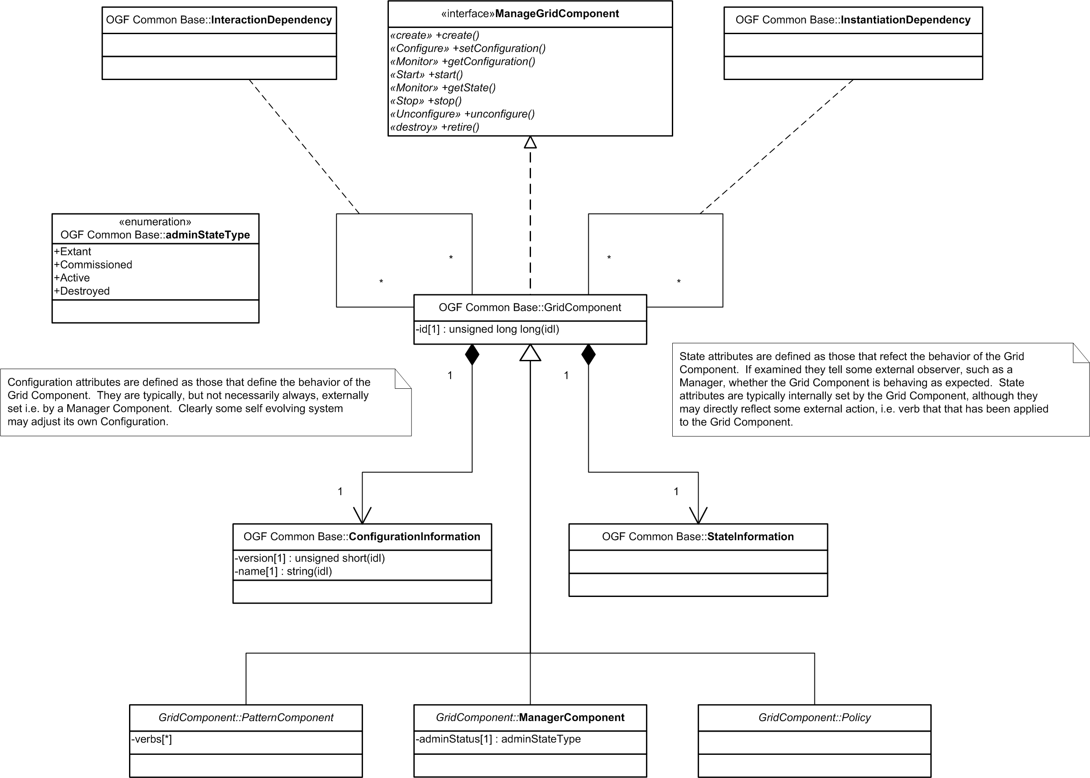
Figure i - The Grid Component
Note that the goal is to keep the abstract part of the model as general as possible, thus most components are lacking everything except the most basic of attributes and operations at this level.
TBD – The following are changes needed to make the above diagram consistent with the V2.0D version of the text herein, i.e. with the revised life cycle material included.
- Change ManageGridComponent to LifecycleManagement.
- Change adminStateType to lifecycleStateType
- Change “adminStatus[1]: adminStateType” to “lifecycleState[1]: lifecycleStateType” and move it to GridComponent. As GridComponent implements the LifecycleManagement interface, it must have the lifecycleState attribute.
- Add “previousLifecycleState[1]: lifecycleStateType”, “commissioningParameterName[n]: TypeName”, and “activationParameterName[n]: TypeName”, to the GridComponent.
- Remove Destroyed from the lifecycleStateType, as it is never observable.
- Change the operations in LifecycleManagement to match the names used in section 2.2.3.2. E.g. Create, Monitor, Commission, Activate, Deactivate, Decommission, Terminate, and Destroy.

The Grid Component
Everything that is managed within a grid is a Grid Component and is represented by the GridComponent class. This is an abstract class that includes configuration and state information, as well as the following base set of attributes and operations.

Common Attributes
- id – a unique identifier for the instance of the Grid Component. For any given system (Grid), such an id should be unique for the lifetime of that system, so as to aid diagnosis and historical event correlation.
- lifecycleState – the lifecycle state of the Grid Component. This equates to the set of defined states in the State Machine diagram for the Grid Component; see Figure ii. Clearly sub-classes of Grid Component may well internally realized, and perhaps externally visible sub-states and additional transitions, or sub-transitions.

Configuration Information Attribute
The ConfigurationInformation class consists of those attributes that define the behavior of the Grid Component. They are typically, but not necessarily always, externally set, for example by a Manager Component. Clearly some self-evolving system may adjust its own configuration.
Specific Configuration attributes include –
- name – a configuration attribute that is just a convenient, preferably easy to remember, name for the Grid Component
- version – the version of the component

State Information Attribute
The StateInformation class consists of those attributes that are typically changed internally within the Grid Component, that describe the run-time state of the Grid Component, and are not Configuration Information parameters. Attributes that define state could be simple state attributes, or they could be volatile attributes of the Grid Component, for example instantaneous or averaged performance metrics.
TBD: We should change the name of this. The word state is used very precisely in the lifecycle state model and this causes some confusion. Ideas: Condition, Internal, private,

LifecycleManagement Interface
This section describes a high-level lifecycle model, state values and operations, for Grid Components. It defines three, extensible high level states that Grid Components can assume and operations to affect transitions between these states. This lifecycle model is intended to provide generic lifecycle monitoring and management functionality. The Reference Model Lifecycle model composes with application specific lifecycle or state models. All the operations for the GridComponent class are exposed through the LifecycleManagement interface.
In a Grid management context, lifecycle monitoring and management functions provide a generalized view of the state of the component as a whole. This section provides a uniform notion of lifecycle states that allow management tools to monitor and control Grid Components without the need to understand the details of how a specific Grid Component is managed. The composable nature of this specification allows existing, component specific notions of lifecycle and state to be maintained in parallel with the generic notions outlined herein.
In some cases the notions of lifecycle management overlap with application specific functions. For example, both the service’s proprietary interface and this lifecycle model may provide for starting and stopping of a service.
Figure ii depicts the Reference Model Lifecycle states and the allowed transitions between them. In the sections that follow these states and the associated transitions are defined. Section 2.2.3.1 defines the main states of the state model and sub-states recommended by this specification.
The notion of lifecycle covers the manageability lifetime of a Grid Component. Section 2.2.3.2 defines the state transition operations that form the basis for lifecycle management. Section defines attributes related to the lifecycle of a Grid Component.
Appendix A – Lifecycle Example WSDL provides a schema and WSDL for the lifecycle state model and transition operations based on the assumption that WSRF Resource Properties [14] specifications are also supported by the implementation. Other approaches to rendering this specification’s formal semantics are of course possible.
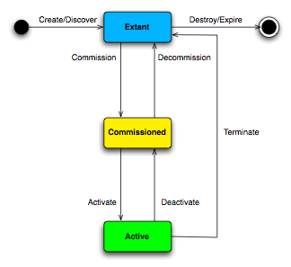
Figure ii - Reference Model Lifecycle States and Transitions

Lifecycle States
The Sate Model consists of three main states, “Extant”, “Commissioned”, and “Active”. Implementations of this specification MUST be able to expose all three states of a Grid Component during the component’s lifetime depending the current state of the Grid Component. These states are defined as follows:
- Extant: The component exists and is manageable. It can be commissioned, but is not ready to become active. It MAY be dependent upon other components.
- Commissioned: The component has been commissioned sufficiently to be activated. All components upon which it depends MUST be either in state Commissioned or Active.
- Active: The component is serving the purpose for which it has been commissioned. All components upon which it depends MUST be Active.
The state model also supports a single level of sub-states. This specification defines eight RECOMMENDED sub states of the top-level states. One primary reason for exposing these sub-states is to enable asynchronous and concurrent lifecycle management, e.g. one management entity has requested commissioning but the process is not yet complete. Those sub states are defined as follows.
- Extant_Failed: This indicates that the Terminate transition occurred because of some unrecoverable error or fault. A Grid Component can reach this state from any other state during its lifetime.
- Extant_Commissioning: This indicates that the commission transition has been requested, but the Grid Component has not yet completed the associated actions to assume the Commissioned state. The previous state of the Grid Component MUST be Extant.
- Extant_Destroying: This indicates that the destruction transition has been requested, but the Grid Component has not yet completed the actions necessary for its own destruction. The previous state of the Grid Component MUST be Extant.
- Commissioned_Commissioning: This indicates that the Commission transition has been requested, but the Grid Component has not yet completed the associated actions to assume the Commissioned state. The previous state of the Grid Component MUST be Commissioned.
- Commissioned_Activating: This indicates that the Activate transition has been requested, but the Grid Component has not yet completed the associated actions to assume the Active state. The previous state of the Grid Component MUST be Commissioned.
- Commissioned_Decommissioning: This indicates that the Decommission transition has been requested, but the Grid Component has not yet completed the associated actions to assume the Extant state. The previous state of the Grid Component MUST be Commissioned.
- Active_Deactivating: This indicates that the Deactivate transition has been requested, but the Grid Component has not yet completed the associated actions to assume the Commissioned state. The previous state of the Grid Component MUST be Active.
- Active_Terminating: This indicates that the Terminate transition has been requested, but the Grid Component has not yet completed the actions to assume the Extant state.
Non-Normative Discussion
Grid Components may be arbitrarily complex or composite in nature. Hence transitions from one state to another may consume considerable resources and time. While the operations defined in this document are synchronous (i.e. the execute and return a result) the completion of the associated actions often is not complete by the time the operation returns. Implementations may indicate the asynchronous execution of those actions by supporting the previously defined sub-states. Alternatively, if the execution of an action is very short-lived, implementations may decide to embed the entirety of the transition in the synchronous handling of the appropriate operation.

State Transition Interface
The state transitions defined here are described in terms of the management operation that a manager would invoke to affect the transition. However, all components MAY perform these transitions based on internal actions. The following is the overall Lifecycle interface.
Operation | Arguments | Result | Faults
Create | any | LifecycleState | CreateFailed
Monitor | AttributeName | AttributeValue | UnknownAttributeFault
Commission | any | LifecycleState | InvalidStateFault
Activate | any | LifecycleState | InvalidStateFault
Deactivate | None | LifecycleState | InvalidStateFault
Decommission | None | LifecycleState | InvalidStateFault
Terminate | None | LifecycleState | InvalidStateFault
Destroy | None | None | DestroyFailed
Create
The Create operation instantiates a Grid Component based on some initial description, which is component specific. The initial description MAY contain all the information to create, commission, and activate the component, or it MAY contain only partial information.
Specification:
Pre:
True
Post:
The component exists and LifecycleState is Extant;
or
The CreateFault was raised.
Monitor
This operation returns the value of the requested attribute if it exists.
Specification:
Pre:
True
Post:
The value of the requested attribute is returned;
or
The UnknownAttributeFault was raised..
Commission
Components in the Extant or Commissioned state MAY be commissioned using the Commission operation. The invoker of the Commission operation MUST provide sufficient information in the invocation parameters for the Grid Component to be ready to become Active. Commissioning MAY require an external service to perform all or part of the commissioning process, which then MUST be given as part of the operation parameters. The returned value for the LifecycleState MUST represent the component’s state at the time the response is generated. Implementations SHOULD return the same lifecycle state as of time of the invocation (either Extant or Commissioned), or one of the sub states defined earlier, to indicate asynchronous processing of the commissioning parameters.
The Grid Component MAY use the operation parameters given to advance directly to the Active state if sufficient information is provided.
If the commissioning process fails, the Grid Component MUST assume the same state as of the time of the invocation of the Commission operation. If the commissioning process fails unrecoverably then the Grid Component MUST assume the state Extant_Failed. If the component is in the Active state when the Commission operation is invoked, the InvalidStateFault MUST be returned. The InvalidStateFault MUST contain the LifecycleState of the component at the time the fault was generated.
Specification:
Pre:
LifecycleState is Extant or Commissioned and the commission operation parameters contain or refer to all necessary information to commission the component.
Post:
The component is ready to become Active and LifecycleState is Commissioned;
or
Commissioning of the component is in progress and LifecycleState is Extant;
or
Commissioning of the component is in progress and LifecycleState is Extant_Commissioning;
or
Commissioning of the component is in progress and LifecycleState is Commissioned;
or
Commissioning of the component is in progress and LifecycleState is Commissioned_Commissioning;
or
The component is Active and LifecycleState is Active
or
The InvalidStateFault was raised and LifecycleState is Active.
Activate
Components in the Commissioned state MAY be activated using the Activate operation. The returned value for the LifecycleState MUST represent the component’s state at the time the response is generated. The invoker of this operation MUST provide enough information in the operation parameters for the Grid Component to become Active.
If the activate process fails, the Grid Component MUST assume the same state as of the time of the invocation of the Activate operation. If the activate process fails unrecoverably then the Grid Component MUST assume the state Extant_Failed. If the component is in the Extant or Active state when the Activate operation is invoked, the InvalidStateFault MUST be returned. The InvalidStateFault MUST contain the LifecycleState of the component at the time the fault was generated.
Specification:
Pre:
LifecycleState is Commissioned.
Post:
The component is Active and LifecycleState is Active;
or
Activation of the component is in progress and LifecycleState is Commissioned;
or
Activation of the component is in progress and LifecycleState is Commissioned_Commissioning;
or
The InvalidStateFault was raised and LifecycleState is unchanged.
Deactivate
Components in the Active state MAY be deactivated using the Deactivate operation. The returned value for the LifecycleState MUST represent the component’s state at the time the response is generated.
If the deactivation process fails, the Grid Component MUST assume the Active state. If the deactivate process fails unrecoverably then the Grid Component MUST assume the state Extant_Failed. If the component is in the Extant or Commissioned state when the Activate operation is invoked, the InvalidStateFault MUST be returned. The InvalidStateFault MUST contain the LifecycleState of the component at the time the fault was generated.
Specification:
Pre:
LifecycleState is Active.
Post:
The component is Commissioned and LifecycleState is Commissioned;
or
Deactivation of the component is in progress and LifecycleState is Active;
or
Deactivation of the component is in progress and LifecycleState is Active_Deactivating;
or
The InvalidStateFault was raised and LifecycleState is unchanged.
Decommission
Components in the Commissioned state MAY be decommissioned using the Decommission operation. The returned value for the LifecycleState MUST represent the component’s state at the time the response is generated.
If the decommissioning process fails, the Grid Component MUST assume the Commissioned state. If the decommissioning process fails unrecoverably then the Grid Component MUST assume the state Extant_Failed. If the component is in the Extant or Active state when the Decommission operation is invoked, the InvalidStateFault MUST be returned. The InvalidStateFault MUST contain the LifecycleState of the component at the time the fault was generated.
Specification:
Pre:
LifecycleState is Commissioned.
Post:
The component is Extant and LifecycleState is Extant;
or
Decommissioning of the component is in progress and LifecycleState is Commissioned;
or
Decommissioning of the component is in progress and LifecycleState is Commissioned_Decommissioning;
or
The InvalidStateFault was raised and LifecycleState is unchanged.
Terminate
Components in the Active state MAY be terminated using the Terminate operation. The returned value for the LifecycleState MUST represent the component’s state at the time the response is generated.
If the termination process fails, the Grid Component MUST assume the Active state. If the termination process fails unrecoverably then the Grid Component MUST assume the state Extant_Failed. If the component is in the Extant or Commissioned state when the Terminate operation is invoked, the InvalidStateFault MUST be returned. The InvalidStateFault MUST contain the LifecycleState of the component at the time the fault was generated.
Specification:
Pre:
LifecycleState is Active.
Post:
The component is Extant and LifecycleState is Extant;
or
Termination of the component is in progress and LifecycleState is Active;
or
Termination of the component is in progress and LifecycleState is Active_Terminating;
or
The InvalidStateFault was raised and LifecycleState is unchanged.
Destroy
Components in the Extant state MAY be destroyed using the Destroy operation.
If the destruction process fails, the Grid Component MUST assume the Extant state. If the destruction process fails unrecoverably then the Grid Component MUST assume the state Extant_Failed. If the component is in the Commissioned or Active state when the Destroy operation is invoked, the InvalidStateFault MUST be returned. The InvalidStateFault MUST contain the LifecycleState of the component at the time the fault was generated.
Specification:
Pre:
LifecycleState is Extant.
Post:
The component no longer exists;
or
Destruction of the component is in progress and LifecycleState is Extant;
or
Destruction of the component is in progress and LifecycleState is Extant_Destroying;
or
The InvalidStateFault was raised and LifecycleState is unchanged.

Lifecycle Attributes
There are four attributes defined for the Grid Component.
LifecycleState: The LifecycleState property contains the current lifecycle state of the component. The legal values are Extant, Commissioned, Active and their substates as defined in Section 2.2.3.1.
PreviousLifecycleState: The PreviousLifecycleState is of the same type as the LifecycleState and contains the previous value of the lifecycle state. This is an optional property.
CommissioningParamterName: The CommissioningParameterName property contains the types that the Grid Component accepts as parameters in the commissioning operation. Clients of the Grid Component SHOULD NOT include arguments that do not appear as a CommissioningParameterNames. Grid Components, however, MAY accept commissioning parameters not advertised as a CommissioningParameterName.
ActivationParameterName: The ActivationParameterName property contains the types that the Grid Component accepts as parameters in the activation operation. Clients of the Grid Component SHOULD NOT include arguments that do not appear as an ActivationParameterName. Grid Components, however, MAY accept commissioning parameters not advertised as an ActivationParameterName.
For Grid Components that support automatic self-activation, the Commission operation contains sufficient parameters for both commissioning and activation. In this case Grid Components SHOULD advertise their ActivationParameterName properties as CommissioningParameterName properties as well.

Associations
At the highest level there are two types of relationships or associations allowed between Grid Components –
- Interaction Dependencies
- Instantiation Dependencies

Interaction Dependencies
Interaction Dependencies are dependencies where one Grid Component interacts directly with another in a peer relationship and are represented in the Reference Model by the InteractionDependency association class. Examples of this dependency include connections and message passing relationships such as –
- Server A is connected to Ethernet Switch B.
- Service C exchanges SOAP message D with service E.
- Management service F manages Operating System G.
These will be modeled as sub-classes of the InterationDependency association class.

Instantiation Dependencies
Instantiation Dependencies are dependencies where one Grid Component depends on another in order for it to be instantiated and are represented by the InstantiationDependency association class in the Reference Model. Examples of this dependency include hosting and compositional relationships such as –
- Operating System A is hosted on Computer B.
- Service C is comprised of sub-services D and E.
These are essentially hierarchical relationships and will be modeled as sub-classes of the InstantiationDependency association class.
NOTE – These relationships may or may not be ordered. For example if a grid component A depends on B and C, it may or may not matter if B must be started before C.
TBD: Discuss how this dependency interacts with lifecycle, e.g. to activate A, B and C must first be activated.

Pattern Components
The PatternComponent class is used to represent or describe Grid Components that have yet to be deployed or managed, and are represented in the Reference Model by the PatternComponent class. These are templates, including some or all of the following: default policies and attributes, constraints and they may also point to the code that executes the code that can manage the associated Grid Component.
TBD: the pattern components may in fact be the creation, commissioning, and activation parameters. If this is correct, the whole thing hangs together quite well.

The Manager Component
The Manager Component represents Grid Components that manage other Grid Components and is represented in the Reference Model by the ManagerComponent class, an abstract sub-class of the GridComponent class. For each logical Grid Component, there is a logical Grid Management Entity grid component that is responsible for managing the life cycle of that grid component. The Manager Component is not necessarily equivalent to a conceptual GME Component. Rather it captures the implemented management system. A Grid Component may be managed by multiple Manager Components, for example one could apply the commission verb, and a different manager could apply the activate verb and so forth. A Manager Component could also manage multiple Grid Components, for example it could implement the activate verb for a wide variety of Grid Component types and instances.

The Policy Class
Policies are managed components within the Enterprise Grid and are represented by the Policy Class. Policies may thus be created and associated with other Grid Components, defining their behavior and/or that of their constituents.
TBD: It is still unclear whether the Policy class itself should be a sub-class of GridComponent. Nonetheless it is clear that it should exist with the Reference Model.

The Relationships Between The Core Grid Component Classes
TBD: The diagram describing the relationships between the component classes needs revising, but wait until we understand the relationship between the creation, commissioning, and activation parameters and these patterns.

The Pattern Component
The Pattern Component describes the base/default configuration, dependencies, constraints, management functionality and policies required for a Manager Component to provision and/or manage its associated managed Grid Component. Pattern Component instances effectively act as service descriptors for their associated Managed Component instances. The complete service descriptor for a service would be a DAG of Pattern Components that would define the default and potential set of DAGs, both of Manager Components and of managed Grid Components.

The Manager Component
Each Grid Component may be managed by a number of Manager Components. The Manager Component may be comprised of a set of sub-components, each responsible for a specific function of the Manager Component, including but not necessarily limited to –
- Policy
- Billing and accounting
- Orchestration
- Service Level Management
- Control
- Monitoring
TBD: It is unclear whether one should consider the “manages” association as a sub-class of the InteractionDependency association class or not.
TBD: Event log entries are generated by both Grid Components and Manager Components, and maintained by Manager Components.

Managed Grid Components
The behavior of each managed Grid Component is defined by a set of policies. This set of policies is effectively maintained by the various Manager Components that enforce them. The policies applied to a given Grid Component include both explicit policies and inherited policies. Policies are not attributes of Grid Components, rather they are separately managed entities within the Grid, and may thus be referenced by many Manager Components. Inherited policies are those that are explicitly associated with a Grid Component higher up the Instantiation Dependency DAG so that they can be propagated to all components of a specific type below that Grid Component. For example a grid component A could have an instantiation dependency on 5 instances of grid component B. A policy that can only be applied to grid components of type B may be explicitly associated with A so that it will be applied to all instances of B that A depends upon. Explicit policies are directly associated with a given Grid Component and override conflicting inherited policies.

Viewing Dependencies
A Grid Component such as a Business Intelligence service may be broken down into other Grid Components, such as a database, application servers and so forth. Likewise Grid Components may be combined or associated, resulting in other Grid Components.
Ultimately decomposition of a Grid Component’s structure resolves to a set of physical Grid Components that cannot be broken down or decomposed from a management perspective.
In fact the dependencies or associations that define a business service or application, i.e. their Instantiation Dependencies, may be represented in the form of a tree, or more correctly (if each connection had an arrow head pointing down to the component depended upon) as a directed acyclic graph (DAG) or acyclic digraph (the two terms are synonymous) – see Figure iii - A Grid Component Instantiation Dependency Graph – below. This particular rendering of the graph, with the connections (edges) between the grid components (nodes) representing Instantiation Dependencies, is useful when considering grid component provisioning. Thus, referring to the diagram below, provisioning of the grid component that is the bookstore requires the provisioning of the persistent storage, business logic and presentation tiers. Provisioning the presentation tier grid component requires the provisioning of the web server farm grid component, and so on, until all of grid components in the DAG are provisioned.
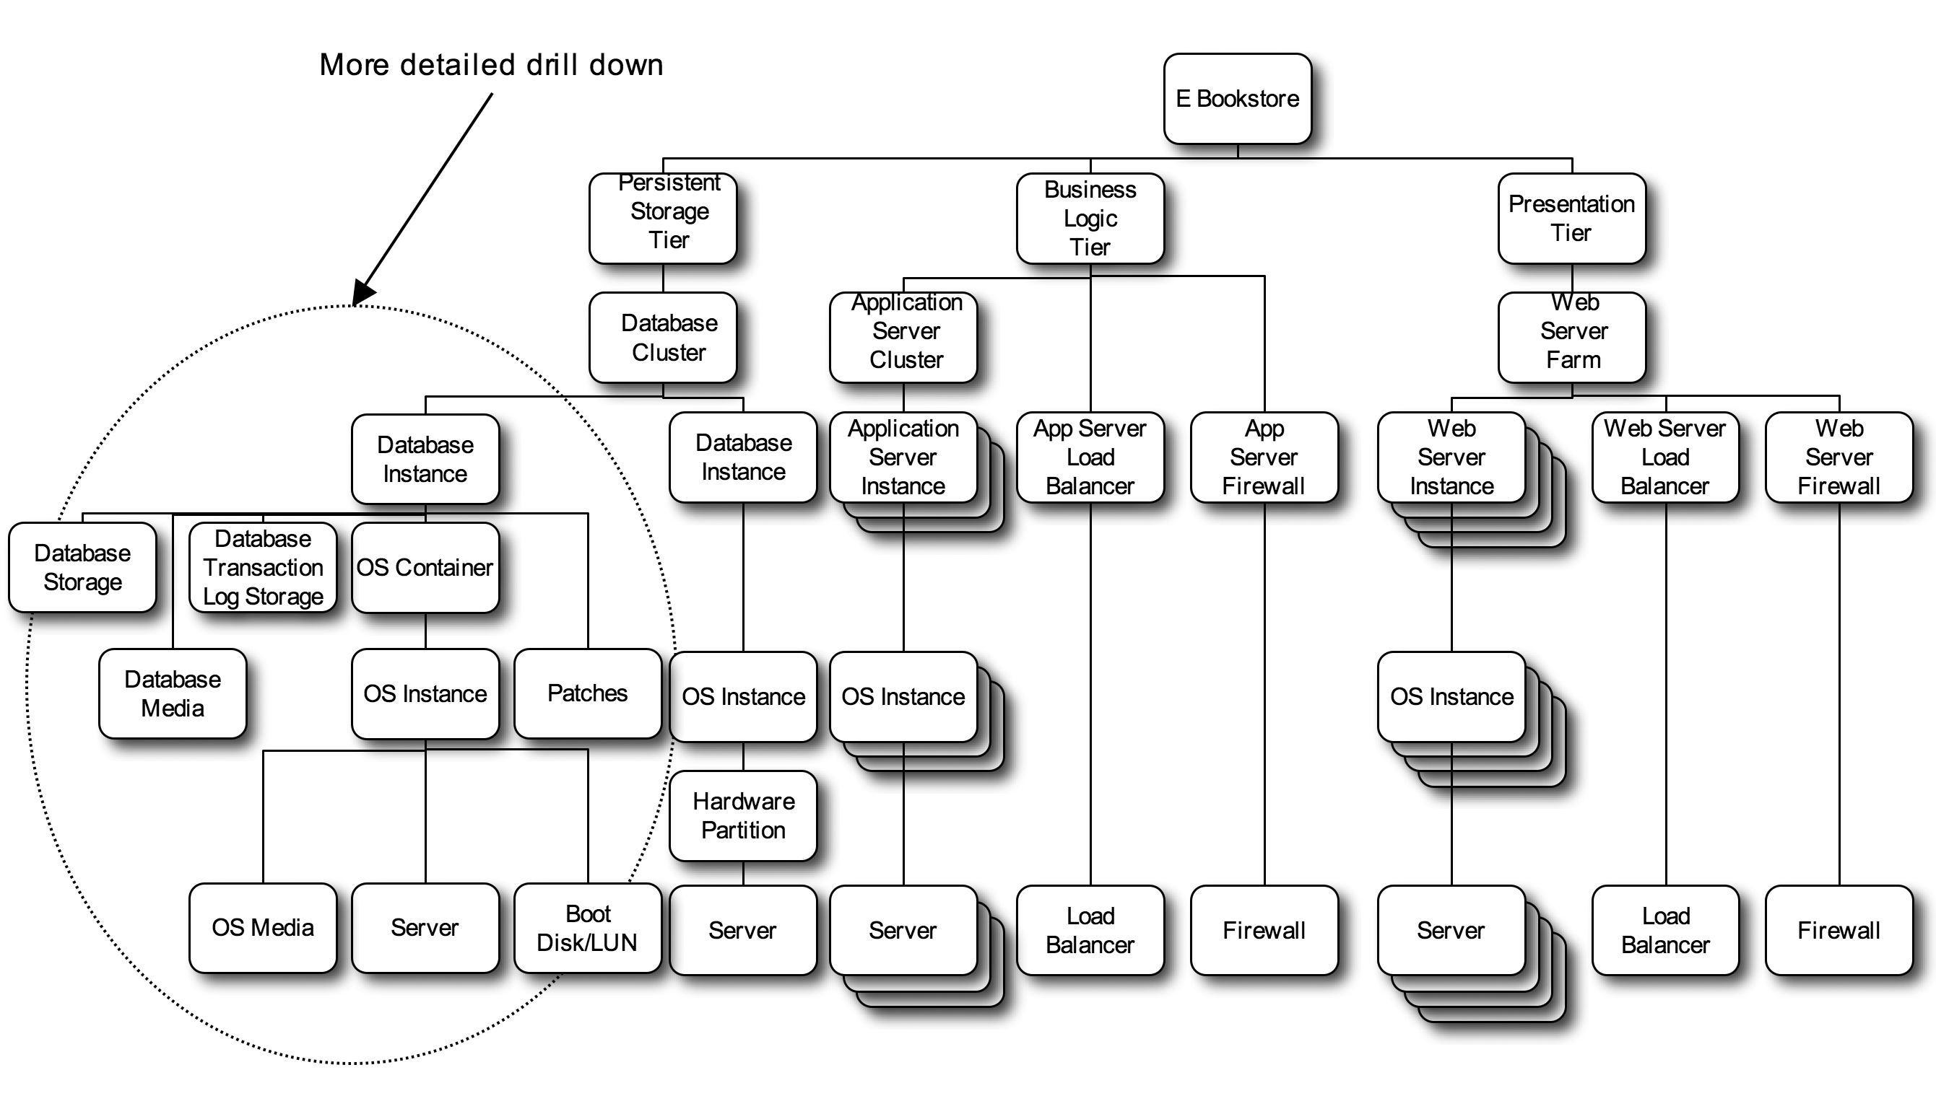
Figure iii - A Grid Component Instantiation Dependency Graph
Other renderings of the graph, with different connections (edges) between the grid components (nodes) may be used to represent performance, scaling, availability and security dependencies. These would be based upon different Interaction Dependencies between the Grid Components.

Attributes and Properties
Grid components have attributes associated with them, such as
- Dependencies or constraints for instantiation, performance, scaling, availability, security and so forth, which may be represented by or deduced from one or more DAGs.
- Service Level Objectives (SLOs) which enumerate the desired attributes of the grid component instance, that would allow the business service or application of which it is a part, to satisfy its Service Level Agreement (SLA). SLOs and SLAs are discussed in more detail in section 2.3.5.2 below.
- Configuration information, which may include versioning, configuration parameters and options, and so forth.
- Data and metrics associated with its state and progress against SLOs.
These attributes may be implemented as internal attributes of a realized grid component or they may only be explicitly implemented as attributes associated with a managed grid component within the Grid Management Entity. The OGF reference model does not make a distinction. It is implementation neutral. – This is discussed in more detail within section 2.3 - The Grid Management Entity.
TBD: Everything beyond this point (until section Appendix A – Lifecycle Example WSDL) is still the original V1.5 text and needs revising!

Classification
In addition to being able to connect grid components together into DAGs to allow for the resolution of various dependencies, it is also possible to group various grid components together into similar groupings or classes that share similar properties.
Figure iv - Some Grid Component Classes – below, shows a possible breakdown of grid components into various classes. The layering of classes and naming is to some degree arbitrary and reflects a view based on provisioning. Thus one would provision from the “bottom up” so to speak.
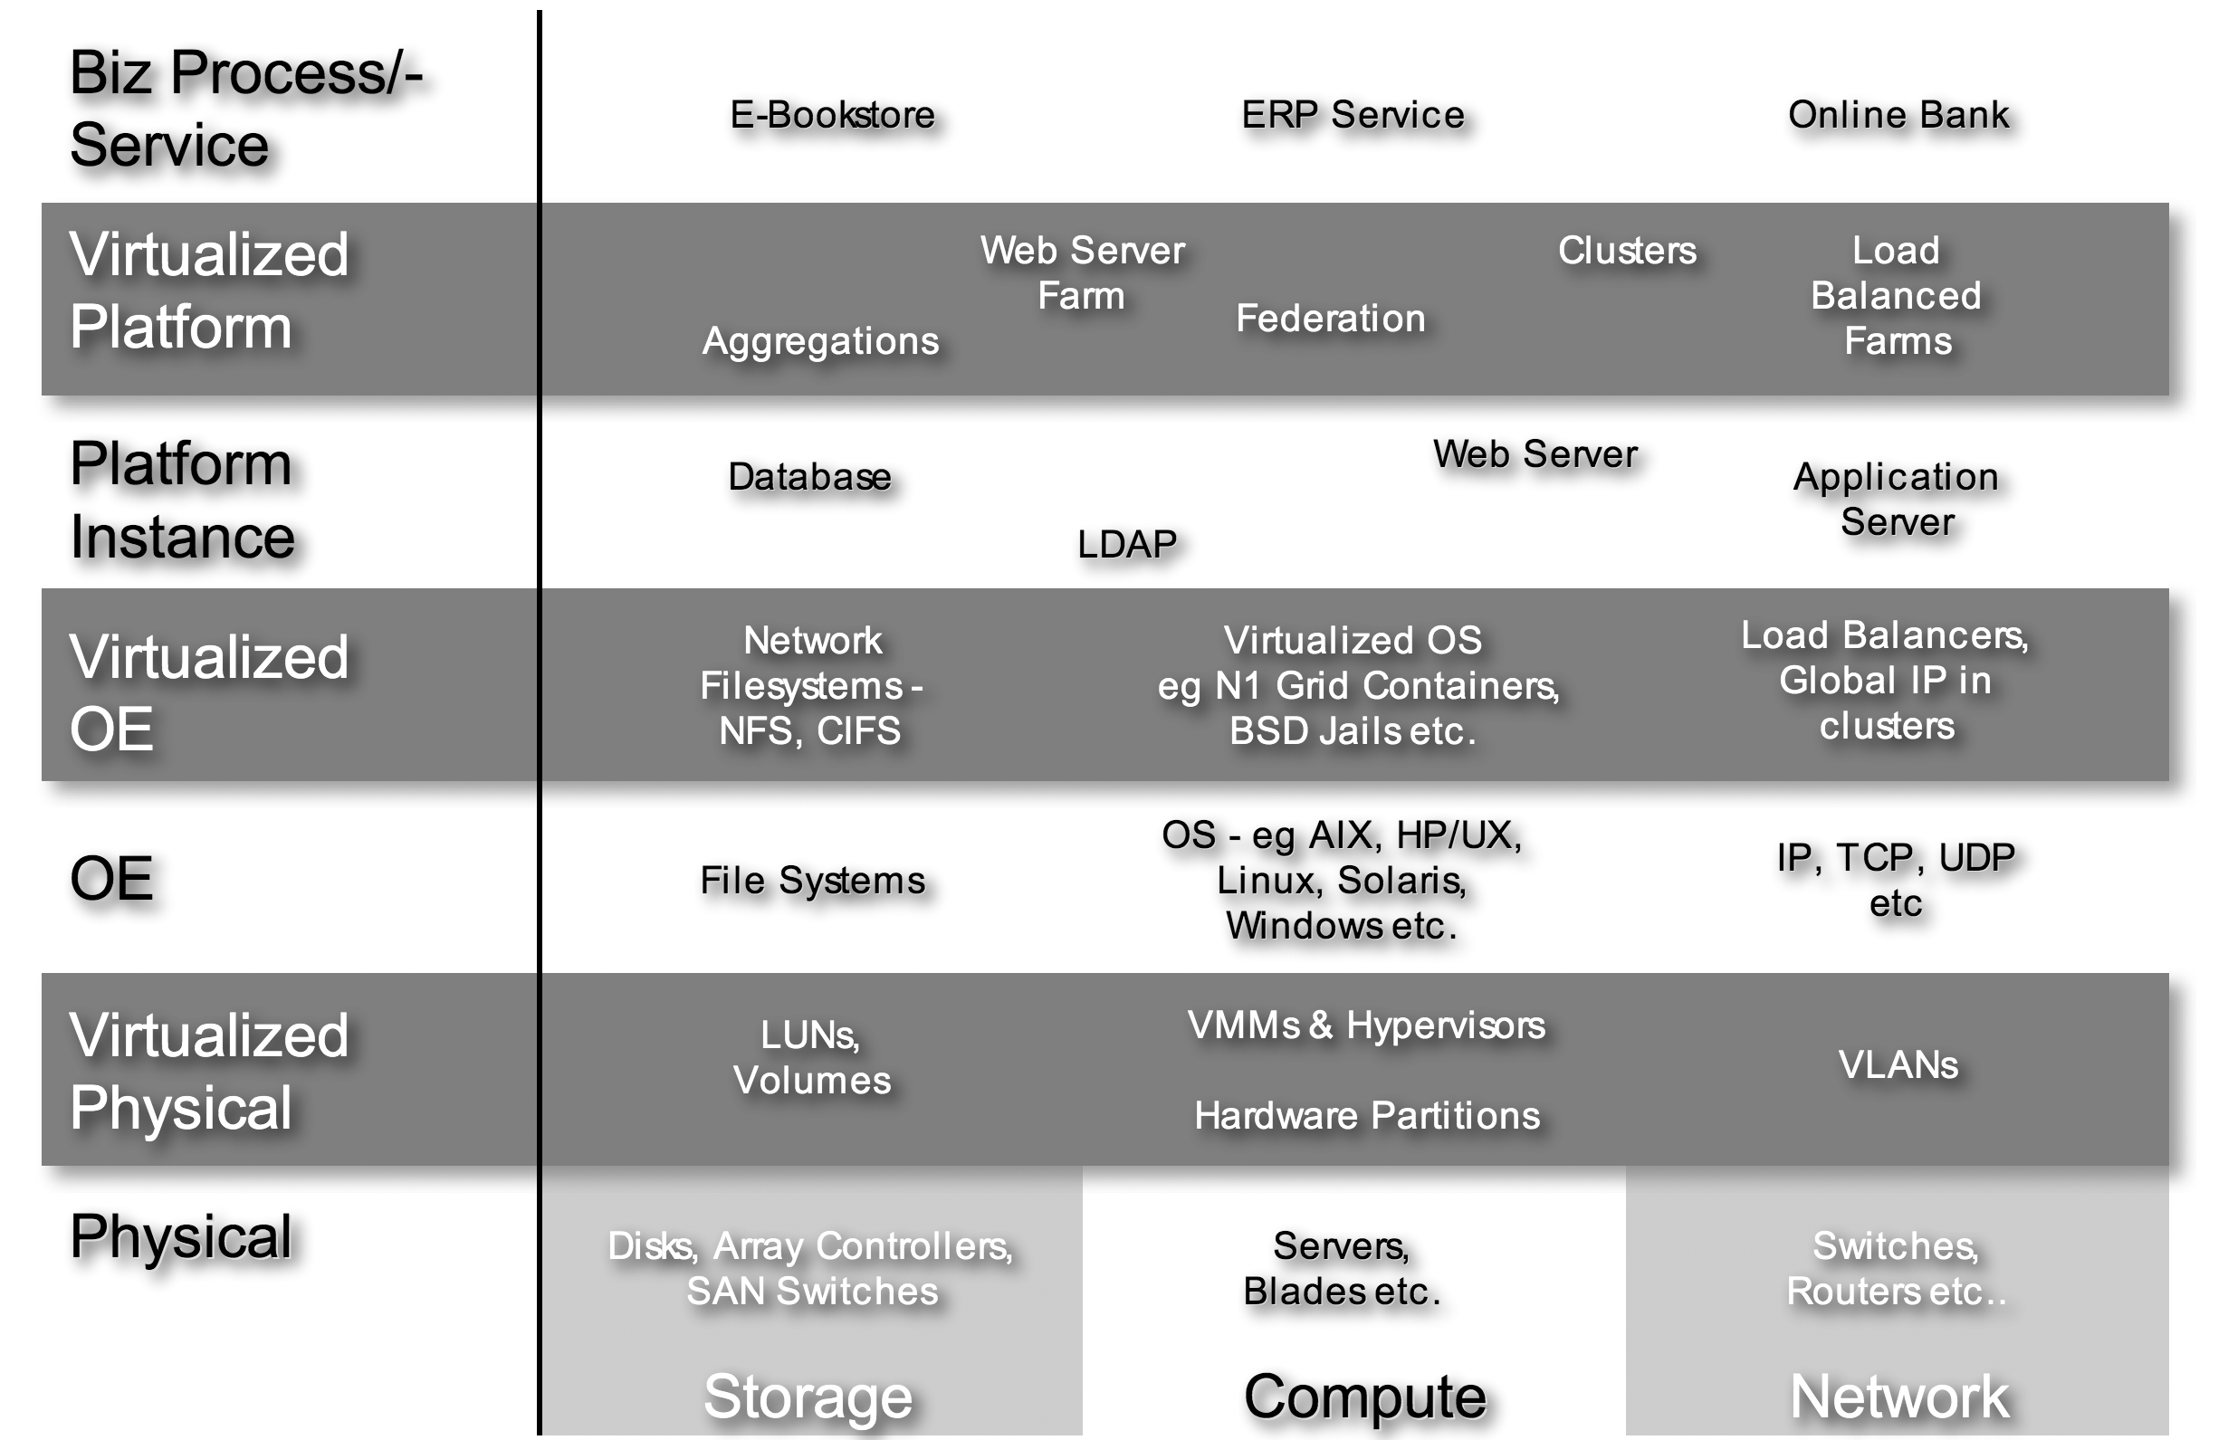
Figure iv - Some Grid Component Classes
The classes of grid components range from the basic physical or elemental grid components to the business processes, which are ultimately realized as services that run on those physical components, as well as everything in between. These include both the managed and managing components.
The various grid components within the data center are shown as layers of increasingly abstract objects. Each layer virtualizes, or abstracts, the one below to enable greater flexibility, efficiency and manageability. At the bottom are physical grid components, which are ultimately, through the layers, related to the business processes that are realized as services, which run on them.
The layers are, from the bottom –
- Physical – Physical grid components are the basic physical building blocks, which comprise the enterprise grid fabric of resources. Examples include, but are not limited to discrete, traditional servers, network switches, disks and so forth.
- Virtualized Physical – Virtualized Physical grid components are those that present essentially the same interface as the physical grid component but which may be realized or implemented differently. For example, a storage LUN presents the interface and properties of a disk, yet the underlying physical component may be a part of a disk, a whole disk or an aggregation, such as a RAID stripe, presented by a volume manager or storage controller. Similarly both hardware partitions and virtual machine managers (VMMs) allow a single rack of resources or a server to host multiple operating environments, each of which behaves as if it had it’s own dedicated server.
- Operating Environment (OE) – OE layer grid components abstract physical grid components, whether virtualized or not, presenting them as resources and making them available to grid components such as services or applications, as well as enabling higher level and more scalable management. These components include such things as file systems, operating environments, IP based LAN segments etc.
- Virtualized Operating Environment – Virtualized OE grid components again present the same essential interfaces and functionality as the OE components, whilst hiding their implementation. As with the virtualized physical devices, the implementations tend to be partitions or aggregations of the original platform component. Thus the virtualized operating environment is realized through technologies such as Solaris Containers or BSD Jails, which essentially partition in some way, a single instance of an operating environment and present each hosted grid component (service) with a customized environment which behaves as if it were a discrete operating system instance. Likewise IP load balancers and global IP addressing in clusters virtualize real IP addresses.
- Platform Instance – The platform instance layer grid components are what one would think of as traditional single instance services or applications, such as an executable binary – e.g. a database server. This may resolve to multiple threads or processes but it may probably be best characterized as an application or service running as an executable on a single instance of an OS. Examples may include, but are not limited to database instances, application server instances, LDAP server instances, mail server instances and so forth.
- Virtualized Platform – Virtualized platform grid components again present the same interface and functionality but may again be a partition of, or an aggregation of platform instance grid components. Examples include load balanced web server farms, application server clusters and database clusters.
- Business Process (Service) – Business processes are complete services realized as aggregations of platform and virtualized platform grid components to fulfill a business function. Examples could be an online bookstore or perhaps an electronic banking service.
Note that any given realization need not include grid components in all layers, and indeed may include many components from within the same layer.
Also note that the various grid components within the physical and virtualized physical layers may also be broken down into components that are typically compute, network or storage focused. This is both potentially useful in that these categorizations are fairly familiar, but also fraught because as one goes up the stack, components may fit into multiple categories. Thus a traditional server (a compute element) may provide routing services or perhaps storage management services. This is represented by the fact that the silos become blurred in the diagram.

Grid Component Summary
The Grid Component concept provides a simple model of the various components within the modern data center, together with their relationships and dependencies on one another. Any given component may be classified in a number of ways depending upon its context or use, yet those components share an essential set of properties and a life cycle.

The Grid Management Entity

Definition
Briefly recapping, the definition of an enterprise grid is
An enterprise grid is a collection of interconnected (networked) grid components under the control of a grid management entity.
The Grid Management Entity (GME) is that logical entity that manages –
- The grid components.
- The relationships between various grid components.
- Their life cycles.
It is responsible for ensuring that the various grid components meet their goals, i.e. that the high level services and applications (e.g. ERP, BI, CRM etc.), deployed on the enterprise grid, meet their service level objectives within their operational constraints.
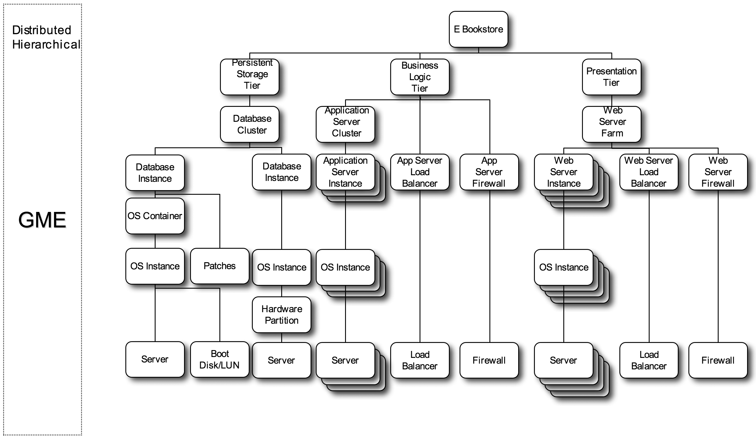
Figure v - The GME As Logically Separate From The Grid Components
It is extremely important to note that the GME is a logical entity into which all management functionality is grouped. This is illustrated in Figure v above, which shows the GME as being logically distinct from the set of managed grid components, in the form of an instantiation dependency graph, which it manages.
The GME may be realized by any combination of people and software tools. Today, in a typical enterprise data center, some of the GME functionality, especially in the areas of policy based provisioning, management and monitoring, is realized in the form of processes undertaken by people. Through time the expectation is that most, if not all, of the processes will move into the technology domain in the form of automated tools. It may be realized by many pieces of software, coupled with people or process, or it could be realized in a single piece of software. The latter is somewhat unlikely given the nature of enterprise grids and the need to scale.
Whilst the GME is logically distinct from the managed grid components, the realization of GME functionality may not be as clearly separate from the realization of the grid components themselves. Thus a given grid component implementation could include management functionality, used to manage other grid components. This management functionality logically resides in the GME even though it is implemented in the grid component. This is illustrated in Figure vi below. In this example, a portion of the dependency graph in Figure v above has been expanded to show that the realized database cluster grid component contains GME functionality.
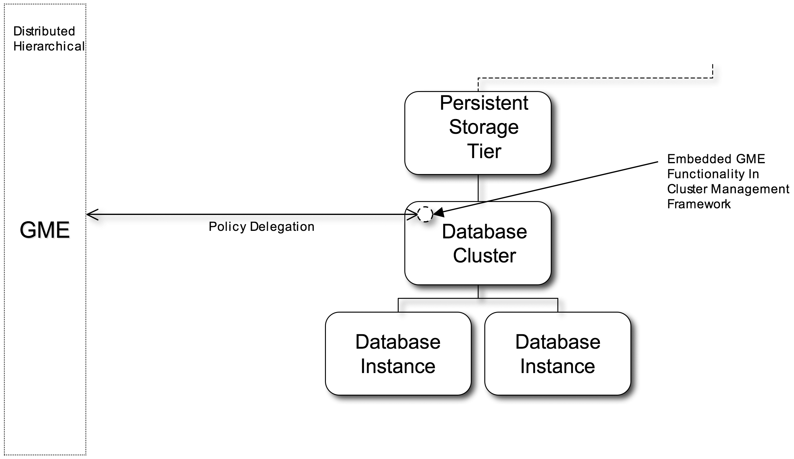
Figure vi - GME Functionality Embedded In Grid Components
Thus the database cluster may be provided with SLOs and constraints with regards to managing the database(s) for which it is responsible. Once the GME has provisioned these database instances and made them available to the database cluster, the cluster may then be responsible for deriving the SLOs for each individual database instance and ensuring that they are met. The database cluster may then interact with the GME to provide updates with respect to progress against objectives or if it needs additional database instances provisioned on its behalf.
This is one of many possible examples showing that the GME is essentially hierarchical and distributed in nature. It also implies that the GME itself may be decomposed in the same way as applications and services, i.e. into grid components.
This example also illustrates the fact that many grid component realizations will include managed attributes/functionality and management functionality.

The Role Of The GME
Having described the general function and form of the GME, its role is now discussed.

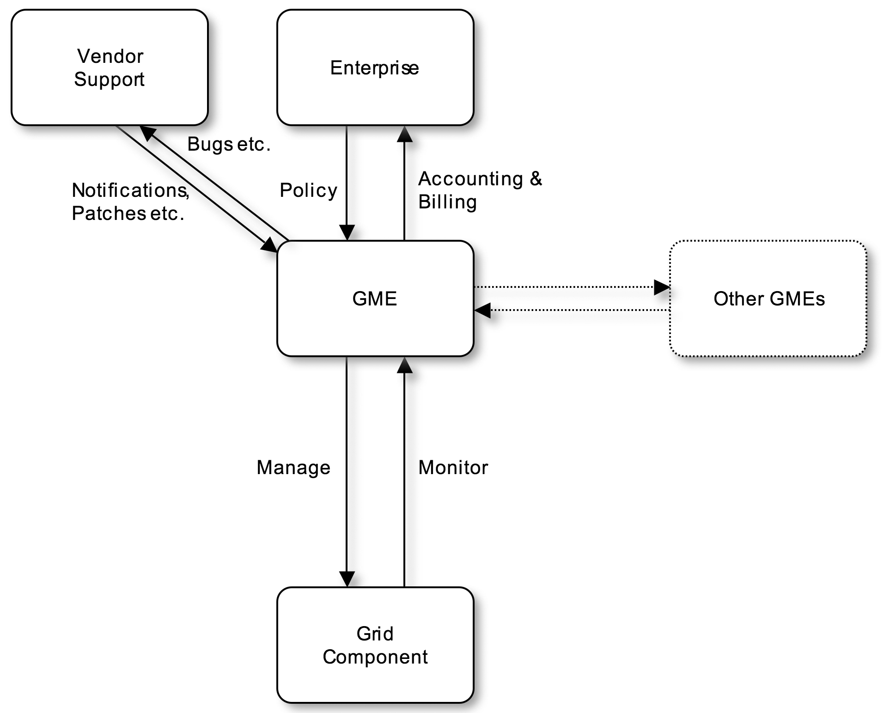
Figure vii - The Grid Management Entity
Figure vii illustrates the role of the GME and it’s interaction with grid components. Whilst the figure shows the interaction with one grid component, the logical GME obviously interacts with all of the logical components within an enterprise grid. Its interaction with a specific grid component is determined by its interaction with the most abstract of grid components, such as a business service, and how that specific grid component contributes or enables that service. This may be deduced through the use of DAGs (see section ).
Referring to Figure vii, the GME is responsible to the enterprise for the application of policy, for example service level objectives (SLOs) and constraints, governing the grid components under its control and for providing the enterprise with feedback, such as accounting and billing information. The higher the level of abstraction of the grid component actively managed, the more efficient the management of the enterprise grid is likely to be.
The GME implements these policies through the management and monitoring of grid components. Management and monitoring includes that of all of the macro phases of the component life cycle (including provisioning and decommissioning), together with more component specific microstates.
The GME also receives external input from entities such as vendors. Examples of this could include security alerts or perhaps patch update notifications, which may modify the policies or constraints applied to a given grid component.
Whilst the interaction of one GME and another is shown, this is only implied and is beyond the scope of this document at present. It is unclear whether the GMEs would constitute an aggregate GME that exhibits the same essential properties and behavior as a single GME, or whether inter GME boundaries exist, where the interactions differ from those within a GME.
The specific policies applied by the GME to a grid component will vary from one grid component to another. In some cases, for example with more abstract applications or services, the policies will be those explicitly specified by the enterprise and may include service level objectives, together with constraints. For simpler grid components, such as a server, some of the policies may be derived by the GME, based on its understanding of how that grid component is related to the more abstract grid components it enables. The role of policy is more fully described in section below.

The Grid Component Life Cycle From The Perspective Of The GME
As already mentioned, the GME is responsible for the provisioning, monitoring, managing and decommissioning of all logically manageable grid components in order to meet the SLAs and SLOs of the business applications or services which they comprise or which depend upon them. This section explores the role of the GME in the life cycle of a grid component in more depth.

The role of the GME includes –
- Setting and getting the various attributes or properties of the grid component, including but not limited to
- Attributes or properties around performance, scaling, availability, security etc.
- Dependencies or constraints for instantiation, performance, scaling, availability, security and so forth.
- SLOs or SLO derived configuration parameters that enumerate the desired attributes of the grid component instance, that would allow the business process or service of which it is a part, to meets its SLOs. For more details please refer to sections (Policy Based Management) and (Service Level Management)
- Configuration information.
- Data and metrics associated with its state and progress against SLOs.
These attributes may be the result of direct operator input or may be derived by the GME via service characterization and sizing (see section 2.3.5.6).
- Managing the various state transitions. These may involve –
- Setting or getting any of the attributes enumerated above.
- Sending notifications.
- Binding or associating a grid component with one or more grid components on which it depends – for example starting a database server on an operating system instance.
- Stopping and unbinding a grid component from others upon which it depends.
- Monitoring the grid component once it is in the active state. This may include
- Receiving notifications.
- Getting any of the attributes enumerated above.

Orchestrating Grid Components
So far the GME discussion has really been limited to defining the GME within the context of enterprise grids and describing its interactions with individual grid components. On a component by component basis this is conceptually simple. However an individual grid component which is a service or business application is actually realized by orchestrating the set of grid components which comprise or are depended upon by it. Some sense of the complexity involved here is illustrated by Figure iii - A Grid Component Instantiation Dependency Graph, which shows just some of the instantiation (installation/provisioning) dependencies for a service or business application.
Thus the GME is responsible for orchestrating all of these components, their life cycles and their relationships with one another. It must manage the installation or creation of a service within the enterprise grid. It must manage that service so that it meets some set of business goals and constraints, and it must provide billing information and other information back to the owners of the service and/or the enterprise grid within which it is deployed.
The GME is analogous to an operating system in that it is responsible for managing the mapping and remapping of workload onto resources in line with goals. A traditional operating environment does this by managing a process and mapping it onto some set of processors based on scheduling priorities. In doing so it allows efficient resource sharing (multiple tasks can share the server), enables flexibility and simplifies management (you don’t need to know which processors a process is using, just how many and the specific processors used can be changed at any time). The GME’s task is similar but somewhat more complex in that it must manage the mapping of complex business applications or services (grid components) onto a networked fabric of resources (enterprise grid) to meet a set of goals (SLOs, business constraints and so forth).
In order to successfully undertake this task, the GME needs a model and internal representation(s), and functionality that captures –
- The set of components to be managed - from servers, disks and switches to complete business services. The grid component provides a simple, generalized component model which may be extended into various classes of component as discussed in section 2.2.11 and illustrated in Figure iv - Some Grid Component Classes.
- The attributes and properties of the grid components, for example type, versions, capacity and so forth.
- The life cycle of these components. A generalized life cycle is presented in section Error: Reference source not found above.
- The relationships and dependencies between these components. These may be represented in a number of ways, one of which is through DAGs, see sections and Error: Reference source not found above.
- Goals such as SLOs that determine the desired performance criteria for each grid component, from business applications to disks or servers.
- Policies that determine what management actions to undertake in order to meet the goals of the service, within the constraints of the enterprise gird, in response to various events or status changes.
- Status information indicating how well a grid component is performing against it’s goals.
- A set of actions or verbs to be applied to the various grid components, to manipulate their life cycles as appropriate in order to meet their goals, see section 2.2.3.2.
The GME also requires a set of mechanisms that enable it to undertake each of the actions enumerated above.
All of the above are required so that the GME can manage the life cycle of a service or business application within an enterprise grid. In combination they enable the GME to use policy and heuristics to manage the life cycle of those applications and meet the goals and constraints of the enterprise(s) that own and host them.

Policy Based Management

General
As discussed in section 2.3.1, the GME essentially applies policies defined by the enterprise to the enterprise grid. The policies applied to the individual grid components may be those articulated by the enterprise or may be derived from them, depending on the nature of the grid component and how it is used. Today, most of the policies associated with managing an enterprise grid are applied by people. It is anticipated that in the future they will be applied by software tools.
These policies may be broken down into –
- Goals
- Constraints
- Configurations
- Rules

Goals - SLOs And SLAs
Goals are typically associated with more abstract grid components, such as a service or application instance, and express the desired operational attributes of that grid component.
Typically goals capture the SLOs of the grid component. For example, the grid component that is a business application, such as an electronic bookstore, could have the following set of SLOs –
- Average book purchase transaction response time of 0.5 seconds
- 80% of book searches return a response in under 2 seconds
- 200,000 concurrent logged in users
- 100,000 concurrent searches
- 30 minutes outage per month for security and software patching
- No unauthorized access to persistent storage or business logic tiers
- Only the bookstore manager may change the SLOs of the bookstore
SLOs may change through time or for pre-determined periods of time, for example the number of concurrent searches or logged on users may be increased if a popular new book is released or a sale is advertised.
In a more general sense, SLOs may also be broken down into the following, non-exhaustive list of categories –
- Response Time requirements
- Capacity requirements
- Volume or Throughput requirements
- Availability requirements – total availability (including both planned and unplanned outage) expressed as a percentage or as real time per month or year for example.
- Reliability requirements – some measure of the reliability, such as MTTF (mean time to failure)
- Recoverability requirements – some measure of recoverability, such as MTTR (mean time to recover) or desired post recovery state.
- Maintainability requirements – some measure of how maintainability, such as maximum required outages for upgrades etc.
- Safety requirements
- Security requirements
These are the typical business level SLOs that would form part of a Service Level Agreement (SLA) for that service. An SLA moves beyond the specification of some set of measurable parameters that define acceptable or desired performance to a legal document that may also articulate the rewards and penalties associated with success or failure in meeting those goals.
Less abstract grid components may also have SLOs. For example a database server that is a part of the bookstore may have a 0.1 second desired transaction response time for book searches.
Note that the role of the GME does not include the explicit interpretation of licenses and SLAs, which are out of the scope of this document. The GME may be provided with SLOs and constraints that may result from such SLAs or licenses, but it is the responsibility of the business that owns the enterprise grid to interpret the terms of any SLAs and licenses, and derive appropriate SLOs and constraints. Otherwise if the GME is responsible for such interpretation and the GME is realized through software then the software vendor may become liable for ensuring that SLAs and license terms are adhered to. It may be the case that this is desirable in certain circumstances. However, for the time being it is easier to simply declare SLA/license interpretation as out of bounds and that the enterprise is responsible for such interpretation and for configuring the GME and appropriate grid components so as to meet their SLA/license obligations.

Constraints
Constraints typically bound the goals of individual applications or services, and for the more abstract grid components may comprise some of the SLOs for the entire enterprise grid. For example constraints for a component could include its priority versus other grid components. Or perhaps define the maximum or minimum set of grid components (for example servers, or licensed instances of a database) that may be used in trying to achieve the SLOs of the service.

Configurations
Each grid component has configuration parameters, even if they are just derived from higher level SLOs rather than explicit SLOs themselves.

Rules
The GME also requires sets of rules so that it can handle events appropriately. These rules may prompt an automatic response or they may simply provide feedback to the enterprise or to an operator. For example rules are required to handle failure to meet an SLO, and which applications or services may be denied resources in order to improve the performance against goal of another application or service.

Applying And Deriving Policy
Ultimately the GME is responsible for ensuring that each grid component meets its goals and is appropriately configured within the operational constraints of the enterprise grid. When a business service is configured within an enterprise grid, the GME is made aware of its general composition (through a DAG or similar) and the SLOs and constraints that apply to it (license or other limits etc.). This is part of creating the grid component that is a business application.
Once the application has been defined or characterized within the GME, the GME then uses its understanding of the application and constraints to determine which other grid components to utilize for the application implementation, (based on their constraints/attributes setup when they were added to the grid by the GME) and to derive the SLOs (derived component-level SLOs) or configuration parameters for them, as well as perhaps the required number of instances. For example the derived SLO for the database component of the bookstore could include –
- 80% of bookstore search requests complete in under 0.15 seconds
- 100,000 concurrent searches
This process may be extended throughout the DAG for a business service, ultimately deriving the requirements for leaf node grid components in terms of processors, memory and network bandwidth for servers and so forth. These requirements are typically configurations rather than goals. Examples of how these derived values may be obtained is discussed in section 2.3.6.2 below.
Note that whilst all of this is done by the logical GME, this does not mean that it is centralized or that there exists a single global policy inference engine. This too may be distributed, with realized grid components that include GME functionality actually deriving some policies for those grid components it manages.

Policy Implementation
It should be noted that just as the general GME functionality is essentially distributed and hierarchical, so too is the policy decision making and enforcement. Using the previous example of a clustered database (see section 2.3.4). The cluster framework may be responsible for determining when a database instance has failed and for requesting that a new instance is started on another operating system instance under its control.

Service Level Management

General
The previous section was focused on policy (see section 2.3.5) and this section is focused on service level management (SLM), the thing that automated policy interpretation and application can enable. SLM is focused on automatically managing services and applications through high level SLOs and is key to enabling the efficient use of enterprise grids. It is SLM that is the process that drives the management of grid components to deliver business value.
Figure viii expands on the role of the GME to emphasize its role in dynamically managing the life cycle and attributes of grid components as part of closed feedback loop SLM. The GME enables a grid component to deliver value by provisioning it or assigning/binding those grid components it depends upon to it (see also Error: Reference source not found). In the general or traditional sense the GME assigns resources (i.e. other grid components), which are then consumed (in some sense) by the grid component. Telemetry associated with the grid component usually allows metrics to be generated. These are then used as input by the GME, which reconciles them with its policies, as well as additional input (for example patch notifications from a vendor) before doing any necessary reassignment or re-provisioning.
NOTE in this section the term resource means any grid component on which the main grid component depends. This could range from an abstract entity such as a database to something physical like processors or a server.

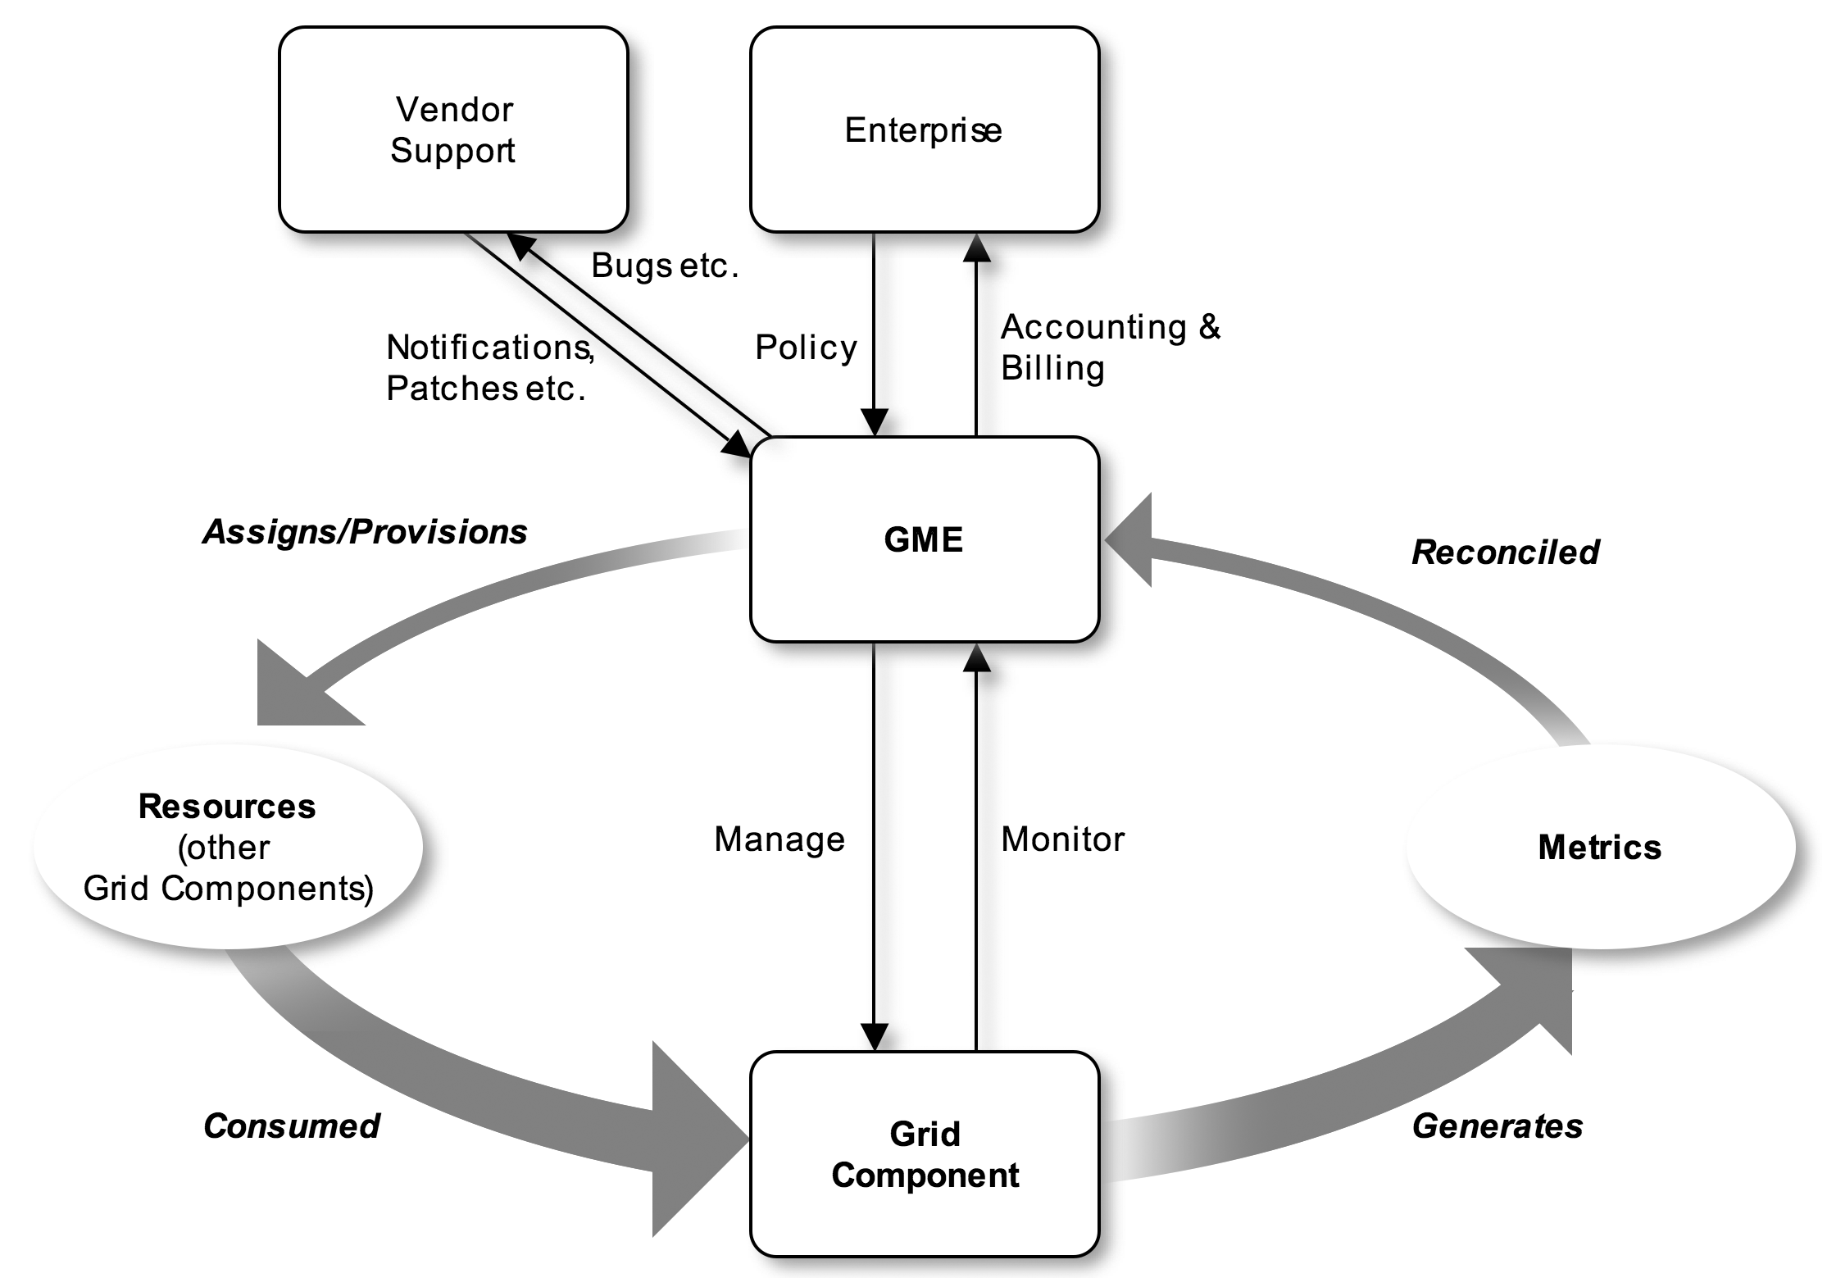
Figure viii - The GME And Service Level Management
As discussed elsewhere, a grid component may be decomposed or viewed as a DAG. Thus the SLM cycle can be applied to every lower level grid component based on the composition of the more abstract grid components, such as an application or service, which it contributes to. In this case the policy input and billing/accounting output could actually be from/to the GME component that manages the next higher level of abstraction. At the highest level of abstraction, the provider of policy and consumer of billing and accounting information is the enterprise itself. This is illustrated in Figure ix - Hierarchical SLM that shows some of the grid components in the top two levels of the DAG for the electronic bookstore. Note that the SLM component for the more abstract grid component may drive the provisioning of a less abstract component, i.e. one that is below it in the DAG. This diagram does not imply that the SLM functional component implements this provisioning. Merely that it controls or initiates it. It may be more appropriate to consider the provisioning to be undertaken by the GME component associated with the grid component to be provisioned.
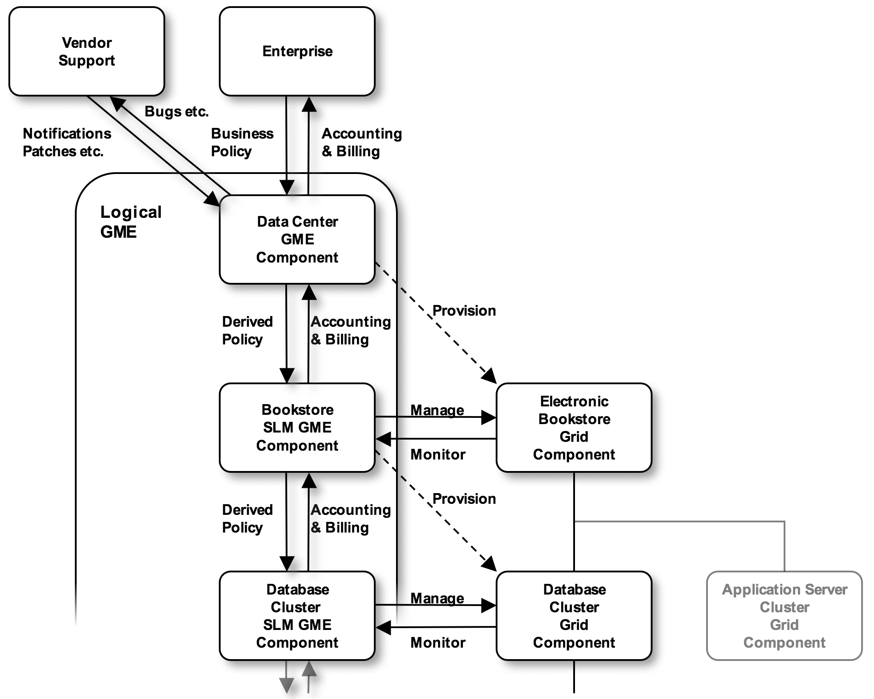
Figure ix - Hierarchical SLM
As an illustration of the fact that whilst the GME functionality may be logically distinct, yet be realized in the implementation of a grid component, Figure x below shows how a database cluster could incorporate both GME and non-GME functionality within a product.
The SLM process may be broken down into two phases –
- Initial Deployment – where some initial policies and configuration parameters define the starting position.
- Ongoing closed loop workload management and optimization.
These are discussed in the following sections.
Note that no assumptions are made about the characteristics of a given workload, nor what a unit of work is, with respect to the EGA reference model.

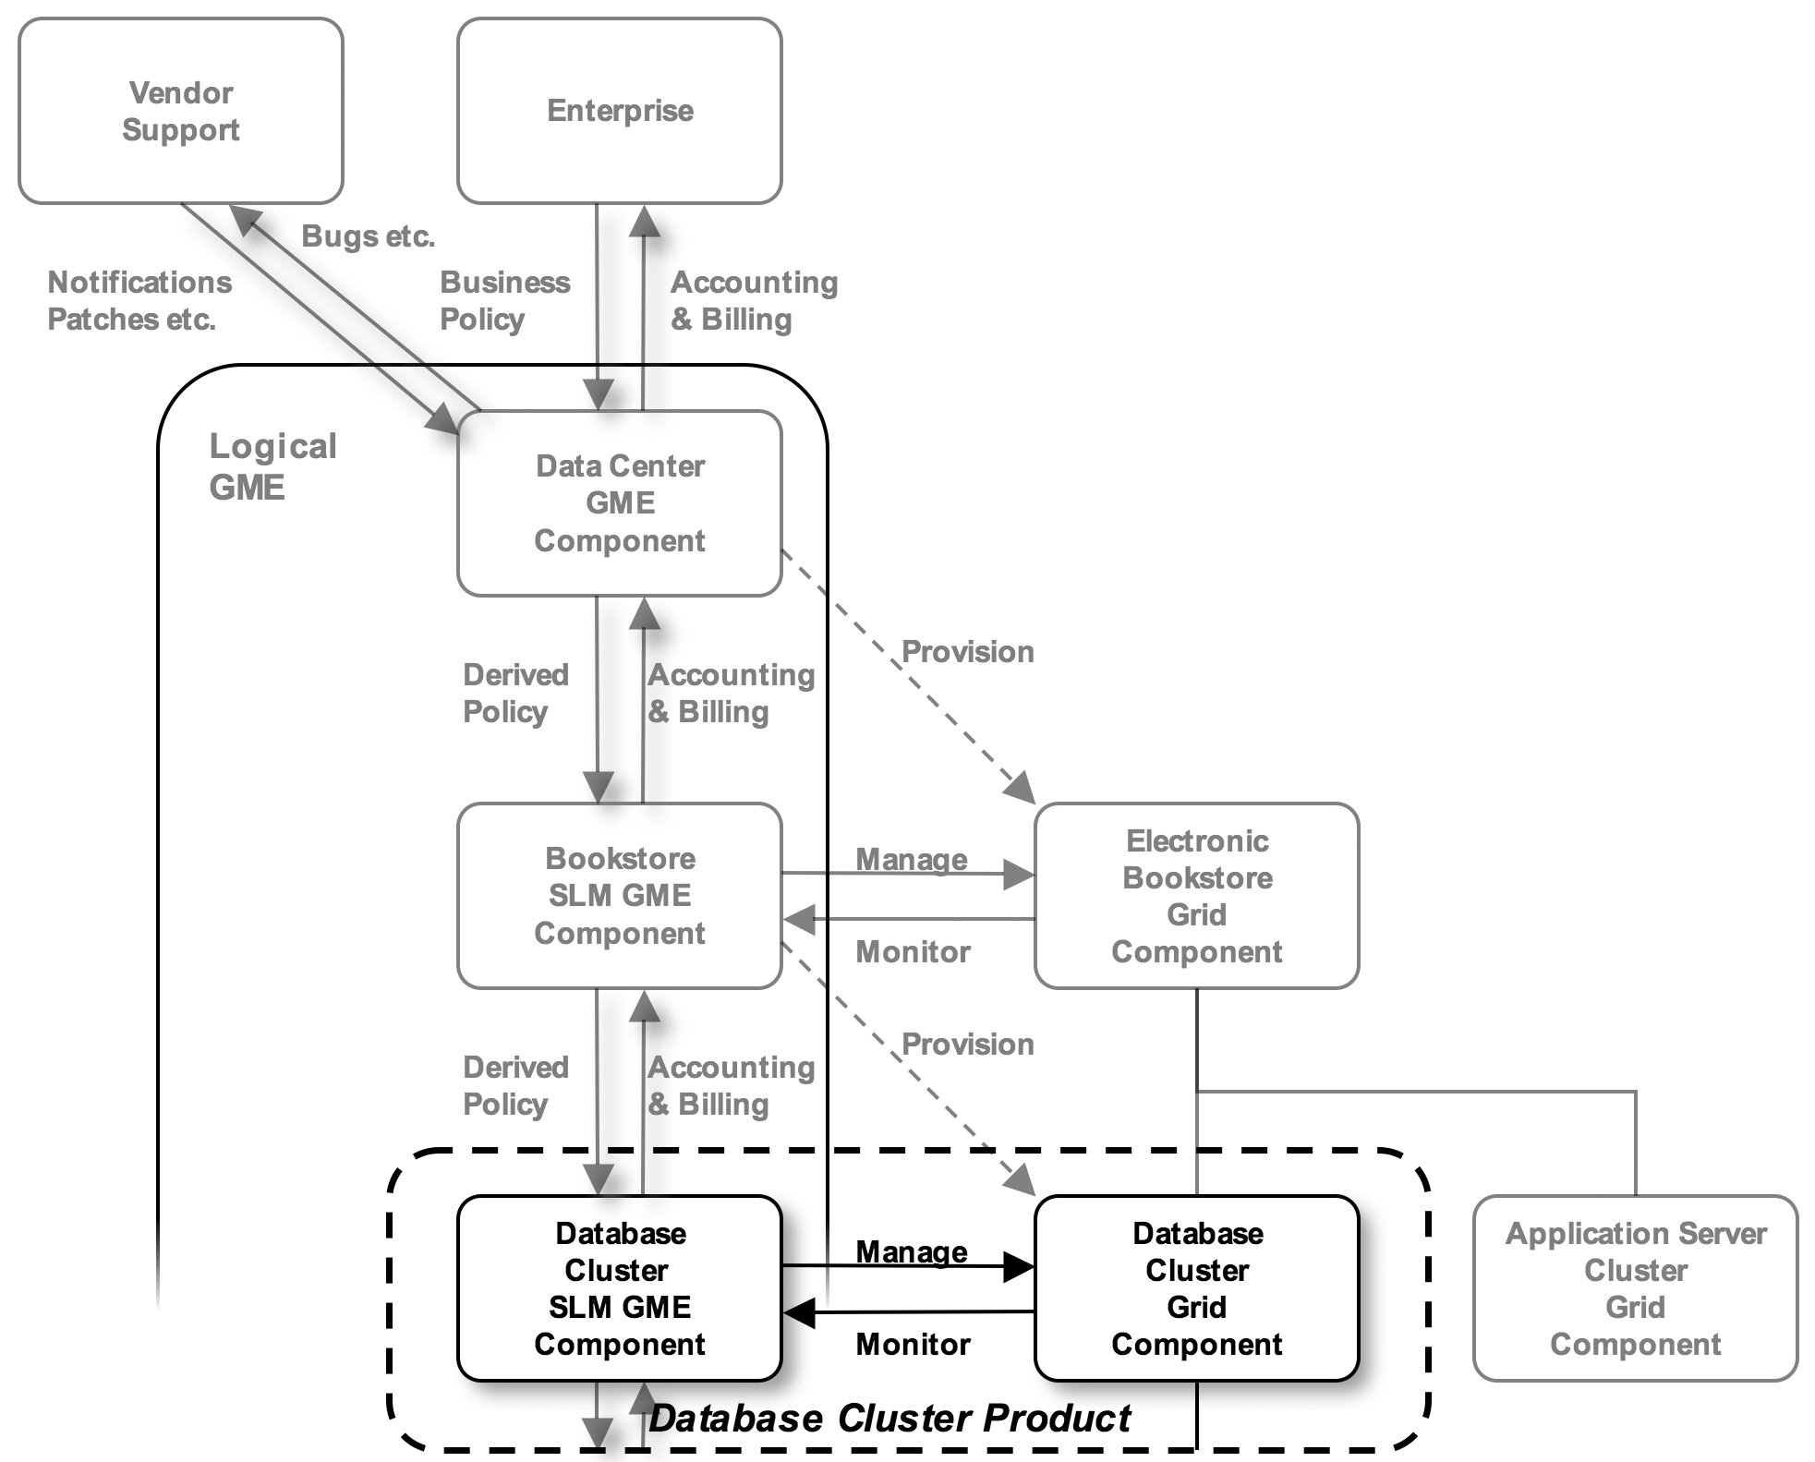
Figure x - Hierarchical SLM showing GME functionality within a realized grid component - i.e. a database cluster
Workloads may range from the completely non-interactive batch type of workload (traditionally called a “job”) to high frequency, short duration transactional workloads which are undertaken by a network of distributed components. Each is undertaken in the same way – a set of related grid components that undertake the work is captured within a DAG, deployed and then managed, prior to decommissioning. Obviously the DAG used to represent performance and scaling dependencies will vary greatly based on the type of workload, as will the rate and number of cycles of the SLM feedback loop when managing that workload. Service characterization and sizing (see below), as well as monitoring and management during the active phase of the life cycle of the workload may also vary greatly. Obviously the less cyclic or transactional and less interactive, the more important the initial characterization, as adjustments will be harder once the work is initiated. Nonetheless the process is common.
What may be called a “unit of work” will vary by grid component and use of that grid component. In many ways this will tie back to the SLOs, or configuration, of a given grid component, and ultimately to the high level SLOs of the service or application and value it delivers. For example at a high level, an electronic bookstore unit of work could be a particular transaction, perhaps a sale. That unit of work is undertaken by a collection of interacting, linked components. The derived unit of work for the database could be a stock lookup. The derived unit of work for the operating environment could be seconds of accrued processor time and megabyte seconds of storage and network bandwidth. Alternatively the unit of work of a weather simulation could range from the whole simulation to the execution of one of the non-interactive simulation elements. The point is that no standard unit of work for the general grid component is easily definable, even though in a grid, the ability to reconcile value delivered by a grid component with the cost and/or resources consumed in delivering it are key to both managing QoS and to enabling effective utility billing and accounting.

Initial Deployment
Before initial deployment of any grid component the GME must first derive its SLOs and configuration parameters. This may be achieved through -
- Service Characterization – the process by which the composition or pattern of a service and the relationships with its dependencies is derived, i.e. creating the DAG(s). Note that a number of different DAGs may be used in characterizing a service. Whilst all of the grid components may be the same, the vertices which join them may differ based on whether the DAG is being used to represent instantiation, performance, scaling, availability or security dependencies.
- Service Sizing – the process by which the number, performance, scaling, availability and security attributes of grid components is derived. This may include
- Application specific benchmarks.
- Capacity planning exercises
- Data gathered from other similar installations
Today there is no satisfactory standard solution for automatically deriving the desired component level SLOs or configuration parameters for grid components. It remains an area where expert manual intervention or execution is required. Nonetheless guidance may be provided by vendors of applications or through the use of standard benchmarks that bear some relation to the target business application. Note that standard benchmarks, whilst providing a ready means of comparison for a very specific workload are often less than representative of actual usage patterns or scaling for many real deployments. Interestingly, the inherent flexibility of enterprise grids means that errors in initial sizing, especially for transactional workloads, can be corrected more rapidly – see section 2.3.6 on service level management below.
Once a business application or service has been characterized and sized with respect to performance, scaling, availability, security and so forth, and this has been input to the GME, then the GME may derive the policies to be applied to all of the grid components that comprise that service, provision them and manage them through their life until the service is decommissioned. This is facilitated by the internal model of the composition of the application as a set of grid components, for example in a DAG (as per Figure iii - A Grid Component Instantiation Dependency Graph).
This activity may include the decommissioning or re-provisioning of other grid components. For example if the set of available server grid components is limited and the new business application takes precedence over one already using some of those components, then the GME may elect to place some grid components (say a web server instance or two) into the inactive state so that the server and/or operating system instance grid component on which they were executing may be repurposed.
Once all of the necessary grid components are available, the business application grid component may be provisioned. This consists of the GME resolving all of the dependencies in the DAG and provisioning each grid component in turn, building on those “below” it until the whole service is provisioned. This is described in more detail in section Error: Reference source not found.

Workload Management And Optimization
Once a grid component has been initially provisioned, then it is be managed by the GME so that it meets its SLOs, as illustrated in Figure viii. Indeed the initial provisioning is equivalent to the resource allocation phase of the first cycle round the loop.

Monitoring
In its role as the service level manager, the GME monitors the provisioned grid component with respect to how it is progressing against its goals, in terms of performance, scaling, availability, security, efficiency and so forth.
Monitoring may be achieved through interacting and gathering monitoring statistics from the grid component itself, or through monitoring those that depend on it or upon which it depends. For example transactional response time may be deduced by querying the database grid component, or by querying the application server that sends queries to the database, or by sending simulated null transactions to the database. Monitoring availability may range from simply checking that the grid component exists to actively querying its state and responsiveness. Monitoring includes both polling and notification mechanisms. The EGA reference model currently makes no assumption about which methods are used, although it does assume both synchronous and asynchronous mechanisms.
It should also be noted that monitoring techniques will likewise vary by workload type, but that again the EGA reference model makes no assumptions with regards to this. For example a long running compute intensive workload or perhaps a batch component of an enterprise application may provide no obvious means of monitoring its progress, as progress is not defined through externally visible repetition, as it is with transactional workload, but by internal state changes and so forth.
Assumptions may be made, and the model modified as and when EGA working groups research these areas and choose to address them.

Reconciliation, Billing & Accounting
At regular intervals, which may vary by grid component and workload type, the GME will –
- Produce billing and accounting information to be fed back to the GME SLM components for the more abstract grid components that depend on it.
- Modify its policies and goals based on new business input, or requirements derived by the GME, for example if another, higher priority grid component is underperforming and requires additional resources. They may also be modified based on other external input, for example if a vendor notifies the GME that certain patches are required to improve security or performance perhaps.
- Reconcile the information gained from monitoring the active grid component, with its policies and goals and adjust accordingly. This is described more fully in the following section.

Resource Optimization And Balancing
The monitoring information gathered by the GME allows it to determine how well the grid component is performing against its various SLOs. If the grid component is failing to meet it’s SLOs, the GME will need to determine whether to adjust the resources assigned to it. It may choose to rebalance resources already at its disposal, or it may request additional resources from other GME SLM components, for example above it in the DAG.
There are many possible methods for doing the rebalancing. All involve the donation of resources from grid components that are over performing, or are of lower priority, to underperforming grid components. Some simply adjust known parameters, one at a time, without seeking to determine the bottleneck, until improvement in the desired dimension(s) is observed. Others may allow the bottleneck to be automatically determined. Some may use trend analysis or other predictive techniques to determine how much resource needs to be reassigned. Trend analysis may be used to drive rebalancing on the fly, or it may be used to track long term cycles, such as quarterly billing or reporting for example. Some simply reassign small fixed quantities at regular intervals until the desired outcome is reached. The appropriate method will depend on many things, including the workload type. The EGA reference model does not assume any specific algorithm.

Reallocating
Once a decision has been made, resources may need rebalancing. This usually means that one or more grid components require reconfiguring or repurposing. Examples include, but are not limited to –
- Moving (decommission and provision) an existing web server grid component from one application to another.
- Provisioning (provision) a new application server instance.
- Changing the number of processors available to a database running on a shared operating system instance or server.
- Changing the number of processors available to a job running on a shared OS instance or server.
- Checkpointing a running job on one server and starting it on another.
- Changing the load-balancing algorithm in a load balancer.
All of these essentially involve the provisioning, decommissioning and reconfiguration of one or more grid components.
As an aside, reallocation is usually only carried out on a small number of grid components at any given time, s as to avoid potentially systemic instability.
Once reallocation is complete the cycle repeats.

GME Functional Breakdown

General
The previous sections have described, in depth, a number of the core areas of the functionality of the GME and the form of the GME. This section summarizes the functional breakdown of the GME.
Firstly the GME may be broken down into logical functional elements (GME components), each of which may, as per the previous section, be distributed within the enterprise grid and each of which is associated with the management of a grid component. This is illustrated in Figure xi below.
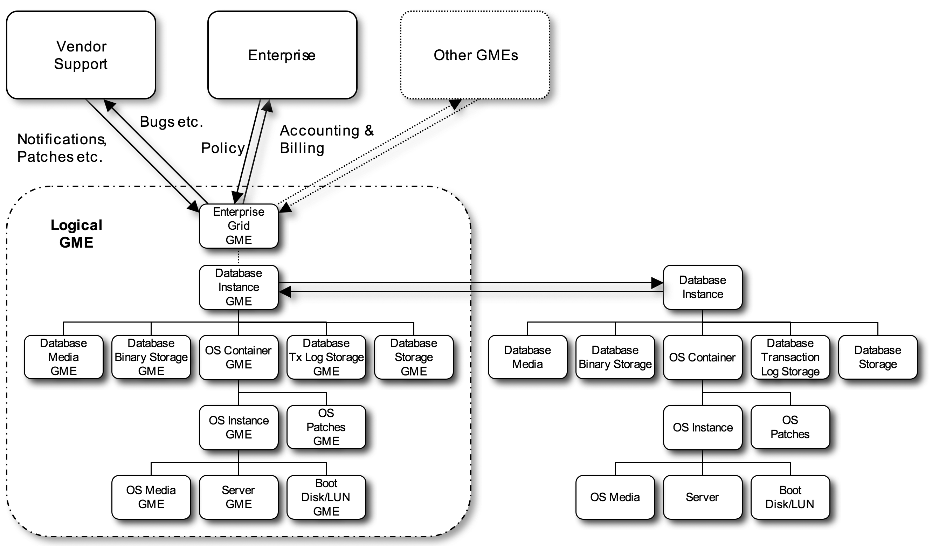
Figure xi - Mapping of logical GME components within the GME to managed grid components
Note that there is a GME component for the enterprise grid as a whole.
Each GME component may be broken down into the following functional areas, each of which has already been described –
- Provisioning/Decommissioning – the act of putting a grid component into the active state. This may include –
- Creation/Discovery
- Configuration
- Starting
- Stopping
- Unconfiguring
- Descruction
- Management/Control – controlling an active grid component. This may include reconfiguring it, changing its state and so forth.
- Monitoring – this may include getting status through polling or receiving notification.
- Service Level Management - this may include management of
- Performance
- Scaling
- Availability
- Security
- Policy – including
- Enforcement
- Derivation
- Billing And Accounting
- Orchestration
This is illustrated in Figure xii - GME Functional Breakdown. The break down is a logical one that can be applied to the logical GME as a whole or to the GME components. Realized GME software products may implement one or more of these functional areas and be associated with one or more realized grid components.
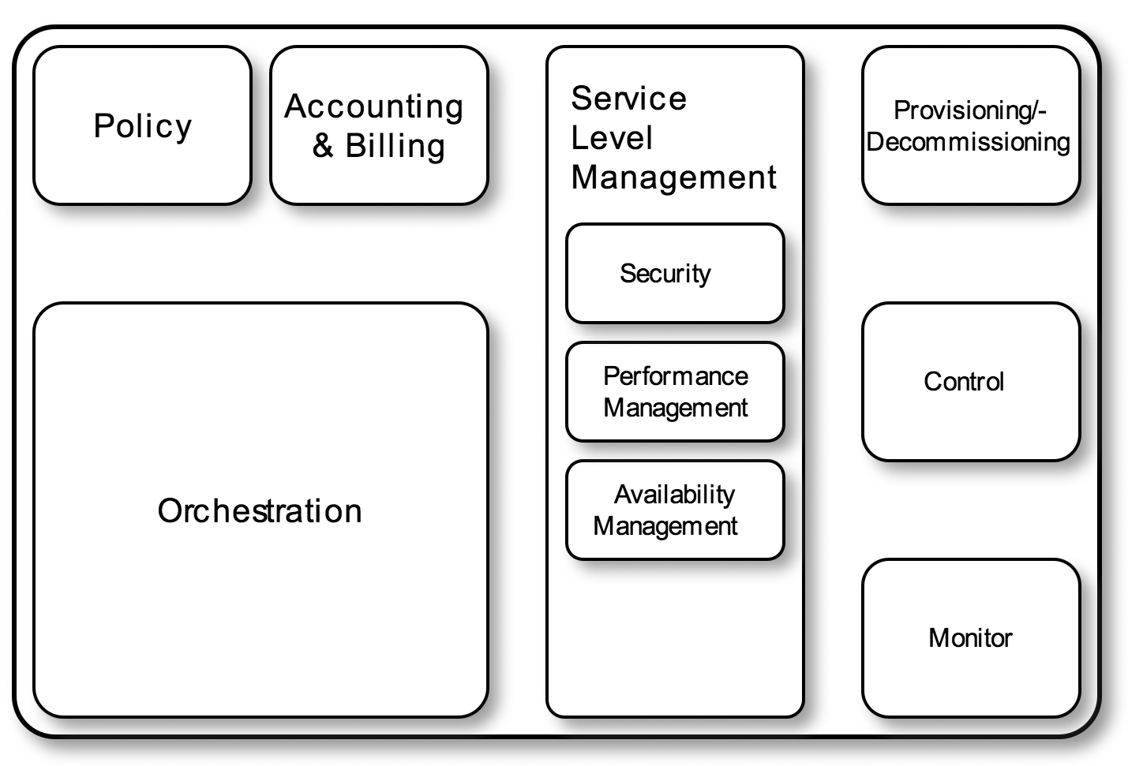
Figure xii - GME Functional Breakdown
[NOTE add GME Repository to the diagram above.]
Figure xii - GME Functional Breakdown, above, captures all of the components of the GME that undertake specific actions. In addition to these the GME also includes the notion of a repository. The GME Repository is the logical repository within which all information about grid components, including their location, connectivity and state, their relationships to each other (as expressed in DAGs), the sets of actions that may be applied to them and log of actions that have already been applied to them, exist. Like the GME itself, the GME repository may be implemented as a monolithic entity (data base) or it may be implemented as a federation of loosely coupled components (databases), distributed amongst any number of products.
NOTE – The GME Repository is analogous to the Configuration Management Database (CMDB) concept within OGC’s ITIL.

GME Summary
The Grid Management Entity (GME) is a logical entity with which all management functionality in the enterprise grid is associated, whether implemented by people or software. That functionality may be realized in discrete components that only serve a management function, or may be embedded within the implementations of certain managed grid components. Thus, the GME is essentially distributed and hierarchical in nature. This also implies that the GME is itself composed of grid components, i.e. GME components whose function is to manage the enterprise grid.

Appendix A – Lifecycle Example WSDL
This appendix contains a WSRF Based Schema and WSDL for the Reference Model Lifecycle Model.
Lifecycle Schema:
<!--
The OGF takes no position regarding the validity or scope of any intellectual property or other rights that might be claimed to pertain to the implementation or use of the technology described in this document or the extent to which any license under such rights might or might not be available; neither does it represent that it has made any effort to identify any such rights. Copies of claims of rights made available for publication and any assurances of licenses to be made available, or the result of an attempt made to obtain a general license or permission for the use of such proprietary rights by implementers or users of this specification can be obtained from the OGF Secretariat.

The OGF invites any interested party to bring to its attention any copyrights, patents or patent applications, or other proprietary rights which may cover technology that may be required to practice this recommendation. Please address the information to the OGF Executive Director.

Copyright (C) Open Grid Forum (2007, 2008). All Rights Reserved.

This document and translations of it may be copied and furnished to others, and derivative works that comment on or otherwise explain it or assist in its implementation may be prepared, copied, published and distributed, in whole or in part, without restriction of any kind, provided that the above copyright notice and this paragraph are included on all such copies and derivative works. However, this document itself may not be modified in any way, such as by removing the copyright notice or references to the OGF or other organizations, except as needed for the purpose of developing Grid Recommendations in which case the procedures for copyrights defined in the OGF Document process must be followed, or as required to translate it into languages other than English.

The limited permissions granted above are perpetual and will not be revoked by the OGF or its successors or assigns.
This document and the information contained herein is provided on an "AS IS" basis and THE OPEN GRID FORUM DISCLAIMS ALL WARRANTIES, EXPRESS OR IMPLIED, INCLUDING BUT NOT LIMITED TO ANY WARRANTY THAT THE USE OF THE INFORMATION HEREIN WILL NOT INFRINGE ANY RIGHTS OR ANY IMPLIED WARRANTIES OF MERCHANTABILITY OR FITNESS FOR A PARTICULAR PURPOSE."

-->
<xsd:schema xmlns="http://www.w3.org/2001/XMLSchema"
xmlns:rmlc="http://schemas.ogf.org/rm/2007/05/lifecycle"
xmlns:wsa="http://www.w3.org/2005/08/addressing"
xmlns:wsrf-bf="http://docs.oasis-open.org/wsrf/bf-2"
xmlns:xsd="http://www.w3.org/2001/XMLSchema"
attributeFormDefault="unqualified"
elementFormDefault="qualified"
targetNamespace="http://schemas.ogf.org/rm/2007/05/lifecycle">

<xsd:import namespace="http://www.w3.org/2005/08/addressing"
schemaLocation="../wsa/ws-addr.xsd"/>
<xsd:import namespace="http://docs.oasis-open.org/wsrf/bf-2"
schemaLocation="../wsrf/bf-2/bf-2.xsd"/>

<!-- Resource Property Related -->

<xsd:simpleType name="LifecycleStateValue">
<xsd:restriction base="xsd:string">
<xsd:enumeration value="Extant"/>
<xsd:enumeration value="Extant_Failed"/>
<xsd:enumeration value="Extant_Commissioning"/>
<xsd:enumeration value="Extant_Destroying"/>
<xsd:enumeration value="Commissioned"/>
<xsd:enumeration value="Commissioned_Commissioning"/>
<xsd:enumeration value="Commissioned_Activating"/>
<xsd:enumeration value="Commissioned_Decommissioning"/>
<xsd:enumeration value="Active"/>
<xsd:enumeration value="Active_Decactivating"/>
<xsd:enumeration value="Active_Terminating"/>
</xsd:restriction>
</xsd:simpleType>

<xsd:complexType name="LifecycleStateType">
<xsd:attribute name="state" type="rmlc:LifecycleStateValue"/>
</xsd:complexType>

<xsd:element name="LifecycleState" type="rmlc:LifecycleStateType"/>
<xsd:element name="PreviousLifecycleState" type="rmlc:LifecycleStateType"/>
<xsd:element name="CommissioningParameterQName" type="xsd:QName"/>
<xsd:element name="ActivationParameterQName" type="xsd:QName"/>

<xsd:element name="LifecycleResourceProperties">
<xsd:complexType>
<xsd:sequence>
<xsd:element ref="rmlc:LifecycleState"/>
<xsd:element ref="rmlc:PreviousLifecycleState" minOccurs="0"/>
<xsd:element ref="rmlc:CommissioningParameterQName" minOccurs="0" maxOccurs="unbounded"/>
<xsd:element ref="rmlc:ActivationParameterQName" minOccurs="0" maxOccurs="unbounded"/>
</xsd:sequence>
</xsd:complexType>
</xsd:element>

<!-- Base Fault Related -->

<xsd:complexType name="InvalidStateFaultType">
<xsd:complexContent>
<xsd:extension base="wsrf-bf:BaseFaultType">
<xsd:sequence>
<xsd:element name="LifecycleState" type="rmlc:LifecycleStateType"/>
</xsd:sequence>
</xsd:extension>
</xsd:complexContent>
</xsd:complexType>
<xsd:element name="InvalidStateFault" type="rmlc:InvalidStateFaultType"/>

<!-- Message Related -->

<xsd:element name="CommissionRequest">
<xsd:complexType>
<xsd:sequence>
<xsd:element name="CommissioningParameters">
<xsd:complexType>
<xsd:sequence>
<xsd:any namespace="##other" minOccurs="0" maxOccurs="unbounded"/>
</xsd:sequence>
</xsd:complexType>
</xsd:element>
</xsd:sequence>
</xsd:complexType>
</xsd:element>

<xsd:element name="CommissionResponse">
<xsd:complexType>
<xsd:sequence>
<xsd:element name="LifecycleState" type="rmlc:LifecycleStateType"/>
</xsd:sequence>
</xsd:complexType>
</xsd:element>

<xsd:element name="ActivateRequest">
<xsd:complexType>
<xsd:sequence>
<xsd:element name="ActivationParameters">
<xsd:complexType>
<xsd:sequence>
<xsd:any namespace="##other" minOccurs="0" maxOccurs="unbounded"/>
</xsd:sequence>
</xsd:complexType>
</xsd:element>
</xsd:sequence>
</xsd:complexType>
</xsd:element>

<xsd:element name="ActivateResponse">
<xsd:complexType>
<xsd:sequence>
<xsd:element name="LifecycleState" type="rmlc:LifecycleStateType"/>
</xsd:sequence>
</xsd:complexType>
</xsd:element>

<xsd:element name="DeactivateRequest">
<xsd:complexType/>
</xsd:element>
<xsd:element name="DeactivateResponse">
<xsd:complexType>
<xsd:sequence>
<xsd:element name="LifecycleState" type="rmlc:LifecycleStateType"/>
</xsd:sequence>
</xsd:complexType>
</xsd:element>

<xsd:element name="DecommissionRequest">
<xsd:complexType/>
</xsd:element>
<xsd:element name="DecommissionResponse">
<xsd:complexType>
<xsd:sequence>
<xsd:element name="LifecycleState" type="rmlc:LifecycleStateType"/>
</xsd:sequence>
</xsd:complexType>
</xsd:element>

<xsd:element name="TerminateRequest">
<xsd:complexType/>
</xsd:element>
<xsd:element name="TerminateResponse">
<xsd:complexType>
<xsd:sequence>
<xsd:element name="LifecycleState" type="rmlc:LifecycleStateType"/>
</xsd:sequence>
</xsd:complexType>
</xsd:element>

</xsd:schema>

Lifecycle WSDL:
<?xml version="1.0" encoding="utf-8"?>
<!--
The OGF takes no position regarding the validity or scope of any intellectual property or other rights that might be claimed to pertain to the implementation or use of the technology described in this document or the extent to which any license under such rights might or might not be available; neither does it represent that it has made any effort to identify any such rights. Copies of claims of rights made available for publication and any assurances of licenses to be made available, or the result of an attempt made to obtain a general license or permission for the use of such proprietary rights by implementers or users of this specification can be obtained from the OGF Secretariat.

The OGF invites any interested party to bring to its attention any copyrights, patents or patent applications, or other proprietary rights which may cover technology that may be required to practice this recommendation. Please address the information to the OGF Executive Director.

Copyright (C) Open Grid Forum (2007, 2008). All Rights Reserved.

This document and translations of it may be copied and furnished to others, and derivative works that comment on or otherwise explain it or assist in its implementation may be prepared, copied, published and distributed, in whole or in part, without restriction of any kind, provided that the above copyright notice and this paragraph are included on all such copies and derivative works. However, this document itself may not be modified in any way, such as by removing the copyright notice or references to the OGF or other organizations, except as needed for the purpose of developing Grid Recommendations in which case the procedures for copyrights defined in the OGF Document process must be followed, or as required to translate it into languages other than English.

The limited permissions granted above are perpetual and will not be revoked by the OGF or its successors or assigns.
This document and the information contained herein is provided on an “AS IS” basis and THE OPEN GRID FORUM DISCLAIMS ALL WARRANTIES, EXPRESS OR IMPLIED, INCLUDING BUT NOT LIMITED TO ANY WARRANTY THAT THE USE OF THE INFORMATION HEREIN WILL NOT INFRINGE ANY RIGHTS OR ANY IMPLIED WARRANTIES OF MERCHANTABILITY OR FITNESS FOR A PARTICULAR PURPOSE.”

-->

<wsdl:definitions name=”Lifecycle”
xmlns=”http://schemas.xmlsoap.org/wsdl/”
xmlns:wsdl=”http://schemas.xmlsoap.org/wsdl/”
xmlns:xsd=”http://www.w3.org/2001/XMLSchema”
xmlns:wsa=”http://www.w3.org/2005/08/addressing”
xmlns:rmlc=”http://schemas.ogf.org/rm/2007/05/lifecycle”
xmlns:wsrf-rp=”http://docs.oasis-open.org/wsrf/rp-2”
xmlns:wsrf-rw=”http://docs.oasis-open.org/wsrf/rw-2”
targetNamespace=”http://schemas.ogf.org/rm/2007/05/lifecycle”>

<!-- Imports -->

<wsdl:import namespace=”http://docs.oasis-open.org/wsrf/rw-2”
location=”../wsrf/r-2/rw-2.wsdl”/>

<!—Types Definitions -->

<wsdl:types>

<xsd:schema
targetNamespace=”http://schemas.ogf.org/rm/2007/05/lifecycle”
elementFormDefault=”qualified”
attributeFormDefault=”unqualified”>

<xsd:include schemaLocation=”./Lifecycle.xsd”/>

<xsd:import namespace=”http://www.w3.org/2005/08/addressing”
schemaLocation=”../wsa/ws-addr.xsd”/>

</xsd:schema>

</wsdl:types>

<!—Fault Messages -->

<wsdl:message name=”InvalidStateFault”>
<wsdl:part name=”InvalidStateFault”
element=”rmlc:InvalidStateFault”/>
</wsdl:message>

<!—Operation Messages -->

<wsdl:message name=”CommissionRequest”>
<wsdl:part name=”CommissionRequest”
element=”rmlc:CommissionRequest”/>
</wsdl:message>
<wsdl:message name=”CommissionResponse”>
<wsdl:part name=”CommissionResponse”
element=”rmlc:CommissionResponse”/>
</wsdl:message>

<wsdl:message name=”ActivateRequest”>
<wsdl:part name=”ActivateRequest”
element=”rmlc:ActivateRequest”/>
</wsdl:message>
<wsdl:message name=”ActivateResponse”>
<wsdl:part name=”ActivateResponse”
element=”rmlc:ActivateResponse”/>
</wsdl:message>

<wsdl:message name=”DeactivateRequest”>
<wsdl:part name=”DeactivateRequest”
element=”rmlc:DeactivateRequest”/>
</wsdl:message>
<wsdl:message name=”DeactivateResponse”>
<wsdl:part name=”DeactivateResponse”
element=”rmlc:DeactivateResponse”/>
</wsdl:message>

<wsdl:message name=”DecommissionRequest”>
<wsdl:part name=”DecommissionRequest”
element=”rmlc:DecommissionRequest”/>
</wsdl:message>
<wsdl:message name=”DecommissionResponse”>
<wsdl:part name=”DecommissionResponse”
element=”rmlc:DecommissionResponse”/>
</wsdl:message>

<wsdl:message name=”TerminateRequest”>
<wsdl:part name=”TerminateRequest”
element=”rmlc:TerminateRequest”/>
</wsdl:message>
<wsdl:message name=”TerminateResponse”>
<wsdl:part name=”TerminateResponse”
element=”rmlc:TerminateResponse”/>
</wsdl:message>

<!—Port Type Definitions -->

<wsdl:portType name=”LifecyclePortType” wsrf-rp:ResourceProperties=”rmlc:LifecycleResourceProperties”>

<wsdl:operation name=”Commission”>
<wsdl:input message=”rmlc:CommissionRequest”/>
<wsdl:output message=”rmlc:CommissionResponse”/>
<wsdl:fault name=”ResourceUnknownFault”
message=”wsrf-rw:ResourceUnknownFault”/>
<wsdl:fault name=”InvalidStateFault”
message=”rmlc:InvalidStateFault”/>
</wsdl:operation>

<wsdl:operation name=”Activate”>
<wsdl:input message=”rmlc:ActivateRequest”/>
<wsdl:output message=”rmlc:ActivateResponse”/>
<wsdl:fault name=”ResourceUnknownFault”
message=”wsrf-rw:ResourceUnknownFault”/>
<wsdl:fault name=”InvalidStateFault”
message=”rmlc:InvalidStateFault”/>
</wsdl:operation>

<wsdl:operation name=”Deactivate”>
<wsdl:input message=”rmlc:DeactivateRequest”/>
<wsdl:output message=”rmlc:DeactivateResponse”/>
<wsdl:fault name=”ResourceUnknownFault”
message=”wsrf-rw:ResourceUnknownFault”/>
<wsdl:fault name=”InvalidStateFault”
message=”rmlc:InvalidStateFault”/>
</wsdl:operation>

<wsdl:operation name=”Decommission”>
<wsdl:input message=”rmlc:DecommissionRequest”/>
<wsdl:output message=”rmlc:DecommissionResponse”/>
<wsdl:fault name=”ResourceUnknownFault”
message=”wsrf-rw:ResourceUnknownFault”/>
<wsdl:fault name=”InvalidStateFault”
message=”rmlc:InvalidStateFault”/>
</wsdl:operation>

<wsdl:operation name=”Terminate”>
<wsdl:input message=”rmlc:TerminateRequest”/>
<wsdl:output message=”rmlc:TerminateResponse”/>
<wsdl:fault name=”ResourceUnknownFault”
message=”wsrf-rw:ResourceUnknownFault”/>
<wsdl:fault name=”InvalidStateFault”
message=”rmlc:InvalidStateFault”/>
</wsdl:operation>

</wsdl:portType>

</wsdl:definitions>

Security Considerations

Please refer to RFC 3552 [12] for guidance on writing a security considerations section. This section is required in all documents, and should not just say “there are no security considerations.” Quoting from the RFC:
“Most people speak of security as if it were a single monolithic property of a protocol or system, however, upon reflection, one realizes that it is clearly not true. Rather, security is a series of related but somewhat independent properties. Not all of these properties are required for every application.
We can loosely divide security goals into those related to protecting communications (COMMUNICATION SECURITY, also known as COMSEC) and those relating to protecting systems (ADMINISTRATIVE SECURITY or SYSTEM SECURITY). Since communications are carried out by systems and access to systems is through communications channels, these goals obviously interlock, but they can also be independently provided.”

Contributors

EGA Reference Model Contributors
Contributor | Organization
Mike Beckerle | IBM
Mukund Buddhikot | Sun Microsystems, Inc.
Debu Chatterjee | Oracle Corporation
Alan Clark | Novell, Inc.
Tim Coulter | Qlusters, Inc.
Michael Enescu | Cassatt Corporation
Brajesh Goyal | Network Appliance, Inc.
Julian Hammersley | Advanced Micro Devices
Masato Kataoka | NEC Solutions (America), Inc.
Raj Kumar | Hewlett-Packard Company
David Pearson | Oracle Corporation
Parviz Peiravi | Intel Corporation
Surendra Reddy | Optena Corporation
Tony Rodriguez | EMC Corporation
Junaid Saiyed | EMC Corporation
Ross Schibler | Cisco Systems, Inc.
Stephen Schleimer | Cisco Systems, Inc.
Michael B Schmitz | Oracle Corporation
Ron Sheen | Fujitsu Siemens Computers
Harald Skardal | Network Appliance, Inc.
Benny Souder | Oracle Corporation
Paul Strong | eBay Inc.
Kazunori Sudo | NEC Solutions (America), Inc.
Bob Thome—editor | Oracle Corporation
Vinod Viswanathan | Optena Corporation

OGF Reference Model 2.0 Contributors
Contributor | Organization
David Snelling | Fujitsu Laboratories, Europe
Michel Drescher | Fujitsu Laboratories, Europe
Paul Strong | eBay Inc.

Glossary

Term | Definition
Abstraction | Abstraction involves changing the interface of an object and exposing it in a more useful or appropriate form. This may be done by providing a layer of software, or whatever, which makes an object or collection of objects easier to manage by exposing a different, abstracted object with a different interface. An example of this would be presenting the user with a tier of a service, for example a tier of web servers and their associated load balancer. The user would then manage the whole tier as a single object, including web tier attributes and load balancing policies, rather than managing each individual component.  See also: Virtualization
Acyclic Digraph | See Directed Acyclic Graph
Commercial Enterprise Application | A class of enterprise application which usually exhibits some of the following attributes -  - Multi-tier architecture  - Interactive, as well as batch components.  - Mostly packaged, often with some customization.  - Centrally managed to enforced standards and policies.  - Operational management to meet defined SLAs.  Examples include ERP, CRM etc.  With respect to enterprise grids, they are typically -  - Hard to change due to architectural inertia and large installed bases.  - Not yet deployed in enterprise grid contexts, i.e. they typically have dedicated silo-ed resources such as servers and storage.  - Proprietary and not yet focused on standards support or interoperability.  See also: Enterprise Application, Enterprise Grid, Service Level Agreement(SLA)
CIM | Common Information Model.
Compute Element | A physical grid component that is a general purpose computer, such as a server.  See also: Grid Component
DAG | See Directed Acyclic Graph
Directed Acyclic Graph (DAG) | A directed graph containing no directed cycles, i.e. closed directed loops.  See also: http://mathworld.wolfram.com/AcyclicDigraph.html
Decommissioning | Decommissioning is the act of putting a grid component into the destroyed state so that it is no longer available to the GME.  See also: Decommissioning, Grid Component, Grid Management Entity
DMTF | Distributed Management Task Force.
Enterprise Applications | The applications or services that are run within modern enterprise data centers. These often exhibit some or all of the following attributes:  - Most run within a single datacenter, there being exceptions for availability, load balancing and co-operative processing.  - Most run within an Enterprise's intranet, exceptions include message-passing applications, for example stock trading applications.
Enterprise Computing | Computing to support the operation of an enterprise.
Enterprise Grid | An enterprise grid is a collection of interconnected (networked) grid components under the control of a grid management entity.  An enterprise grid is typically managed by a single enterprise - i.e. a business entity is responsible for managing a pool of resources, and a set of services, and for managing the assignment of resources to services in order to meets its business goals. The resources and services may or may not be owned by the business, for example in the case of managed services or a service provider/outsourcer. What defines the boundaries of the enterprise grid is management responsibility and control.  The services that run on an enterprise grid may range from the traditional commercial enterprise applications, such as ERP or CRM packaged applications, to newer, distributed applications or services.  Enterprise grids are typically differentiated from more traditional data centers by management practices and technology which –  - Make management service or application centric, rather than component centric.  - Enable the pooling and sharing of networked resources.  - Enable agility through rapid and automated service provisioning.  An enterprise grid may be confined to a single data center or it may extend across several.  For more information see [NOTE - insert section with longer description]  See also: Grid Component, Grid Management Entity, Provisioning, Resource, Service
Enterprise Grid Computing | A form of grid computing, specifically within an enterprise, resulting in an enterprise grid that includes commercial enterprise applications as a type of workload/service.  See also: Commercial Enterprise Applications, Enterprise Grid, Grid Computing
GGF | Global Grid Forum.
GME Component | A super-class of object that represents the management functionality within the logical GME that is associated with a grid component.  See also: Grid Component, Grid Management Entity
GME Repository | The GME Repository is the logical component of the GME in which all of the configuration, state, audit and event logging information for an enterprise grid is stored. The GME repository is a logical entity and may be realized in number of ways, including but not limited to –  - A single, discrete database  - A federation of discrete databases  - A federation of databases and flat files, some discrete and some internal to specific GME component or grid component implementations.  The GME repository is directly analogous to the CMDB in ITIL.
Grid Component | The grid component is a super class of object that represents every managed entity, whether physical or logical, within an enterprise grid.  Grid components are recursive, in that they may be aggregated to form other grid components, or decomposed into their constituent grid components.  Examples of grid components include, but are not necessarily limited to –  - Traditional resources such as servers, switches, disks, arrays and routers. These are considered to be elemental grid components.  - Less obvious resources such as a software distribution or perhaps data.  - Services, such as CRM, ERP etc.  - Everything in between. Thus, for example, an ERP service may be decomposed into database, application server and web tiers. These may in turn be decomposed into instances that are bound to operating system instances and servers. Each of these is considered to be a grid component.  Whether a grid component is viewed as a service or as a resource and depends on context.  Each grid component has a life cycle which has to be managed and may include a number of phases, which may include –  - Add  - Configure  - Start  - Stop  - Unconfigure  - Remove  See section [Insert here] for a fuller description of the grid component and its life cycle, as well as classifications of various types of grid component.  See also: Enterprise Grid, Resource, Service
Grid Computing | The use of pools of resources onto which applications or services may be dynamically provisioned and re-provisioned to meet the goals of one or more enterprises, whilst improving both efficiency and agility.  Grid computing environments may be typified by  - the use network distributed, shared pools of discrete resources to achieve greater performance, scaling, resilience and utilization  - flexibility or mutability, as components are regularly repurposed or re-provisioned in line with the business goals for the services that run on them  - a focus on services, rather than on components, as grids turn networks into arbitrarily rich/complex fabrics of resources.  - application or service architectures which are disaggregated or distributed in nature, for example Service Oriented Architectures (SOAs) and which leverage the properties of the fabric of resources.  - the consolidation of computing components into [typically] a smaller number of larger resource pools to enable easier provisioning and greater resource utilization.  - the standardization of components and/or their interfaces, configurations, processes and applications. Virtualization is an example of this – see section 2.  Grid computing is subtly different from Utility Computing, which includes most, possibly all of the attributes of grid computing, but implies a pricing model associated with the usage of a grid computing environment, together with enabling concepts and technologies such as standard units of work/value and metering.  See also: Utility Computing
Grid Management Entity (GME) | The grid management entity (GME) manages all of the grid components within an enterprise grid, including –  - their relationships with one another, for example mapping operating systems and applications onto servers and networks  - their life cycle, for example discovering, configuring, starting and stopping components.  The GME may be realized –  - Through people and process  - Through technology  - A combination of the above.  The GME provides the context for understanding the key problems associated with managing enterprise grids and grid components today.  See also: Enterprise Grid, Grid Component
Horizontal Scaling | See Scale Out.
ITIL | The Information Technology Infrastructure Library. ITIL is a cohesive set of best practices around service and infrastructure management developed and published by the OGC. ITIL has been widely adopted by both government and commercial organizations as the basis for their internal data center and IT management processes.  See: Section Error: Reference source not found, Error: Reference source not found  See also: OGC
OGC | The Office of Government Commerce. The OGC is an independent office of the treasury of the UK government, and is the body responsible for the development and publication of the ITIL best practices.  See also: ITIL
OGSA | Open Grid Services Architecture.
Network Element | A physical grid component that is a networking device, such as a switch or router.  See also: Grid Component
Pool | A pool is a set of grid components. Membership of a pool is dictated by membership criteria, which may range from explicit assignment to the pool by an operator, to implied membership such as sharing a common state. The pool may be persistent or non persistent. For example a non-persistent pool could be one that exists momentarily during a decision making process when some set of components that are candidates for some operation needs to be determined. Membership of a pool could make a member a subject of an aggregate verb (one which when applied to the pool is then applied to each member) perhaps or a candidate for a member specific verb. Of course there may be pool specific properties and verbs too.  See also: Grid Component
Provisioning | Provisioning is the act of putting a grid component into the active state so that it is available to a consumer of the service or resource it supplies. No assumptions are made as to the starting state of the grid component.  See also: Decommissioning, Grid Component
Resource | Resources, in the most general sense, are things, usually physical or logical components, onto which services are provisioned. Resources are considered to be grid components within the context of the EGA reference model. Examples include server hardware, network switches, disc arrays, software media and so forth.  See also: Grid Component
Scale Out | Scale Out is the term usually applied to scaling an application or service through the use of multiple service component instances, which typically resolves to additional operating system instances and/or servers too (plus clustering frameworks of various forms). This is synonymous with Horizontal Scaling. A typical example of a service that scales out is a web server tier of a multi-tier service.  See also: Horizontal Scaling
Scale Up | Scale Up is usually applied to scaling an application or service by increasing service performance and/or capacity through making more resources available to an instance of a service or service component, typically within a single instance of an operating environment and/or server. This is synonymous with Vertical Scaling.  See also: Vertical Scaling
Service | A service in the most general sense is something, usually one or more software components, which responds to client requests. An electronic bookstore application is a service. The database component of the bookstore provides a data base service to the bookstore. Thus high level, abstract services may be recursively decomposed into lower level constituent services. In general, a service and all off its decomposable sub services are considered to be grid components within the context of the EGA reference model.  In general the term should be qualified or its meaning made obvious through context.  See also: Grid Component
Service Characterization | The process by which the composition or pattern of a service and the relationships with its dependencies is derived.  See also: section 2.3.6.
Service Level Agreement (SLA) | An agreement between the provider and consumer of a service which stipulates a set of properties or attributes that the service must satisfy, possibly together with a definition of the payment and/or penalties associated with meeting or failing to meet the agreed criteria.  See also: Service Level Objective
Service Level Objective (SLO) | The specific quantifiable and measurable attributes of a service that form the basis of a Service Level Agreement.  See also: Service Level Agreement
Service Processor | A component of a physical server which runs independently of that server’s operating system and main processors, memory and IO, and which allows the physical platform to be managed independently of whether the server is booted or not, or has an operating system installed or not.
Service Sizing | The process by which the number, performance, scaling, availability and security attributes of grid components is derived.  See also: section 2.3.6.
Storage Element | A physical grid component that is a storage component, such as a disk or array.  See also: Grid Component
Technical Enterprise Applications | A class of enterprise application which usually exhibits some of the following attributes -  - Often highly parallel  - Heavily batch oriented.  - Mostly heavily customized.  Examples include Rendering, Portfolio Simulation, Finite Element Modeling etc.  With respect to Enterprise Grids, they are typically -  - Easier to change due to inherent customization.  - Already deployed in some Enterprise Grid contexts.  - Often driven by cooperative processing and some focus on standards support or interoperability.  See also: Enterprise Application
Utility Computing | Utility Computing is a term often applied to IT infrastructure and technology which really captures the fact that that infrastructure may be paid for or may deliver services which may be paid for based on use or value rather than on component cost. The analogy being with a typical electrical grid. It is implied that there is a standard set of billable units and appropriate metering capabilities.  Grids, by their nature, will be service centric and will require telemetry that will enable reconciliation of resources with the services that consume them, i.e. cost with value, and thus to some degree they enable utility computing. Nonetheless there is a subtle distinction between a compute utility and a grid, typically in terms of the use of metering, billing, rating and so forth.  See also: Enterprise Grid Computing, Grid Computing
Vertical Scaling | See Scale Up.
Virtual Machine Monitor/Manager (VMM) | A layer of software or firmware/microcode that sits between one or more operating systems and a server. It presents each hosted operating environment with the impression that it has it’s own dedicated server, although in reality they all share the same physical server.  See also: Virtualization
Virtualization | Adding a software abstraction layer onto some entity so that the new entity exhibits the interface properties of the original or a normalized interface broadly similar to that of the original. This layer hides the true implementation of the virtualized entity so that the original can be changed or replaced without fundamentally impacting the interaction of entities that have a dependency on it. The abstraction layer may allow a single entity to be partitioned and presented as a set of virtual entities, or it may allow a set of discrete entities to be treated as a single aggregate entity. An example is disk LUNs, which present the interface of a disk, yet may be implemented as a whole disk, a partition of a disk or perhaps an aggregation such as a RAID stripe.  Note that virtualization is specific type of abstraction that seeks to preserve the interfaces and general properties of the abstracted entity.  See also: Abstraction
VMM | See Virtual Machine Monitor/Manager

Intellectual Property Statement
The OGF takes no position regarding the validity or scope of any intellectual property or other rights that might be claimed to pertain to the implementation or use of the technology described in this document or the extent to which any license under such rights might or might not be available; neither does it represent that it has made any effort to identify any such rights. Copies of claims of rights made available for publication and any assurances of licenses to be made available, or the result of an attempt made to obtain a general license or permission for the use of such proprietary rights by implementers or users of this specification can be obtained from the OGF Secretariat.
The OGF invites any interested party to bring to its attention any copyrights, patents or patent applications, or other proprietary rights, which may cover technology that may be required to practice this recommendation. Please address the information to the OGF Executive Director.

Disclaimer
This document and the information contained herein is provided on an “As Is” basis and the OGF disclaims all warranties, express or implied, including but not limited to any warranty that the use of the information herein will not infringe any rights or any implied warranties of merchantability or fitness for a particular purpose.

Full Copyright Notice
Copyright © Open Grid Forum (2007, 2008). All Rights Reserved.
This document and translations of it may be copied and furnished to others, and derivative works that comment on or otherwise explain it or assist in its implementation may be prepared, copied, published and distributed, in whole or in part, without restriction of any kind, provided that the above copyright notice and this paragraph are included on all such copies and derivative works. However, this document itself may not be modified in any way, such as by removing the copyright notice or references to the OGF or other organizations, except as needed for the purpose of developing Grid Recommendations in which case the procedures for copyrights defined in the OGF Document process must be followed, or as required to translate it into languages other than English.
The limited permissions granted above are perpetual and will not be revoked by the OGF or its successors or assignees.

References
[NOTE - These need sorting, formatting etc.]
- [EGA] “EGA Reference Model and Use Cases v1.5” Part 2 of 2, Enterprise Grid Alliance, 10 March 2006.
- [DMTF] Distributed Management Task Force (DMTF), http://www.dmtf.org
- [CIM] DMTF Common Information Model (CIM), http://www.dmtf.org/standards/cim
- [FOSTER] I. Foster et al., “The Open Services Grid Architecture, Version 1.0”, Global Grid Forum, Lemont, Illinois, U.S.A., GFD-I.30, 2005, http://www.ggf.org/documents/GWD-I-E/GFD-I.030.pdf
- [OGF] Open Grid Forum (OGF), http://www.ogf.org
- [SNIA] Storage Networking Industry Association, http://www.snia.org
- [ITIL] ITIL - http://www.itsmfusa.org/mc/page.do?sitePageId=2995
- [ETOM] eTOM - http://www.tmforum.com/browse.asp?catID=1647
- [BRADNER1] Bradner, S. Key Words for Use in RFCs to Indicate Requirement Levels, RFC 2119. March 1997.
- [BRADNER2] Bradner, S. The Internet Standards Process – Revision 3, RFC 2026. October 1996.
- [CATLETT] Catlett, C. GFD-1: Grid Forum Documents and Recommendations: Process and Requirements. Lemont, Illinois: Global Grid Forum. April 2002.
- [RESCORLA] Rescorla, E. Guidelines for Writing RFC Text on Security Considerations. RFC 3552. July 2003.
- [OGSAGLOSS] OGSA Glossary
- [WSRF-RP] WSRF resource Properties Specification.

